Daisy (Armant) Ross-Poche

November 27, 1916 – October 9, 1980

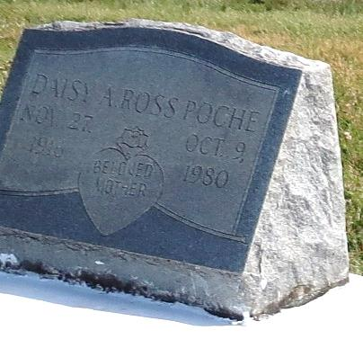

Mrs. Daisy Ross Poche, 63, a native and resident of Wallace, La., died 10:15 a.m. Thursday at West St. James Hospital in Vacherie.

Visitation begins at 6 p.m. today at St. Phillip Catholic Church Hall in Vacherie. A rosary is scheduled for 8 p.m. today at the church hall. The funeral will be 11 a.m. Tuesday at St. Phillip Catholic Church with burial following in the church cemetery.

Survivors include her first husband, Walter Ross; her second husband, Florence Poche; three sons, Ural Ross of New Orleans, Walter Ross of Wallace and Gerald Ross of Thibodaux; seven daughters, Shirley Gibson of New York City, Mildred Hall of New Orleans., Barbara Jackson and Earline Stevens of Las Vegas, Nev., Geraldine Rayfield of Boutte, Janice Lumar and Marie Johnson of Wallace; a stepson, P. Lewis of Westwego; five stepdaughters, Shirley Nicholson and Laura McDonald of Lutcher, Varine Doris of Westwego, Marion Poche of Kenner, Earline Johnson of New Orleans. Other survivors include four brothers, Wilfred Armant, Joseph, Charles and Morris Almore; five sisters, Agnes Steib, Rosemary Murry, Ula Poche, Leola Dumas and Lillian Montgomery; 31 grandchildren; 25 step grandchildren, seven great-grandchildren and 31 step great-grandchildren.

She is preceded in death by her parents, Adolph and Emily Armant.   
 Earl Baloney and Sons Funeral Home is handling arrangements.

Houma Courier, Terrebonne Parish, LA; Oct. 13, 1980, Monday