Walter Ross
August 11, 1945 – February 11, 2024

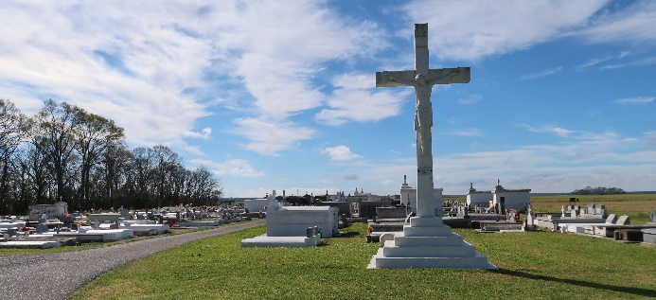

Walter “Wala” Ross, a native of St. John the Baptist Parish. Was born August 11, 1945. He was born to Daisy and Walter Ross Sr. and was a resident of Wallace Louisiana. He peacefully departed this world on February 11, 2024, at the age of 78. Walter married the love of his life, Lovenia Lewis and to this union two children were born: Catina Harry and Tevin Lewis of Vacherie LA.
Walter attended 2nd Ward High School and continued to become a Construction Worker. “Wala” loved spending time with family, drinking, cooking, cutting grass and sitting on the porch while talking to family and friends.
He leaves cherish his fondest memories to his wife, Lovenia; children, Catina Ross Harry (Otis) and Tevin Lewis; grandchildren Essence and Emeril Harry, and Ebony Lewis; siblings, Shirley Gibson, Janice Lumar (Wilfred), Barbara Jackson, Earline Stevens, and Gerald Ross, and a host of nieces, nephews, Godchildren, family and friends.
A public visitation will be held on Sunday, February 18, 2024 at Treasures of Life Funeral Services, 315 E. Airline Hwy., Gramercy, LA 70052 from 3PM-5PM. A Mass of Christian Burial will be held on Monday, February 19, 2024, at St. Philip Catholic Church, 1175 LA-18, Vacherie, LA 70090. Visitation beginning at 9M with Mass to follow at 11AM. Interment at St. Philip Catholic Church Cemetery.

Treasures of Life Funeral Services, Gramercy, Louisiana
February 16, 2024

