Clifton A. Roussel Sr.

August 31, 1925 – May 23, 2008

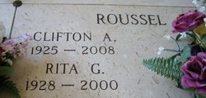 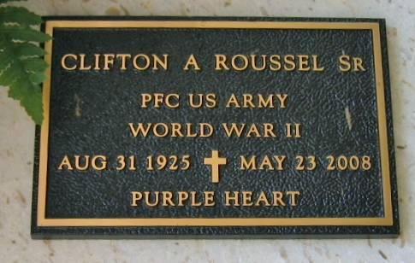

Photos by Bobby

Clifton A. Roussel, Sr. of Vacherie, LA on Friday, May 23, 2008 at 4:40 PM. Beloved husband of the late Rita G. Roussel. Father of Patricia Stroud, Annette Weisler, Allen, Wayne and Clifton Roussel, Jr. Son of the late Theodore Pierre Roussel and Elizabeth Tassin Roussel. Brother of Ann Bowen, Elaine Dugas, Deacon Ted Roussel and the late Harold, Lloyd, Lawrence and Theodore Roussel. Also, survived by 12 grandchildren, 8 great-grandchildren and a host of nieces and nephews. Age 82 years. A native of Wallace, LA and a resident of Marrero, LA. Relatives and friends of the family are invited to attend visitation on Tuesday, May 27, 2008 from 6PM until 10PM at MOTHE FUNERAL HOME, 2100 Westbank Expressway, Harvey, LA. Visitation will continue on Wednesday, May 28, 2008 from 9AM until Mass time at 11AM at St. Philip Catholic Church, Vacherie, LA with burial in St. Philip Cemetery. Information: 366-4343.

Times-Picayune, The (New Orleans, LA)

Monday, May 26, 2008