Ashley Elizabeth Rousseve

December 16, 1994 – March 12, 2006

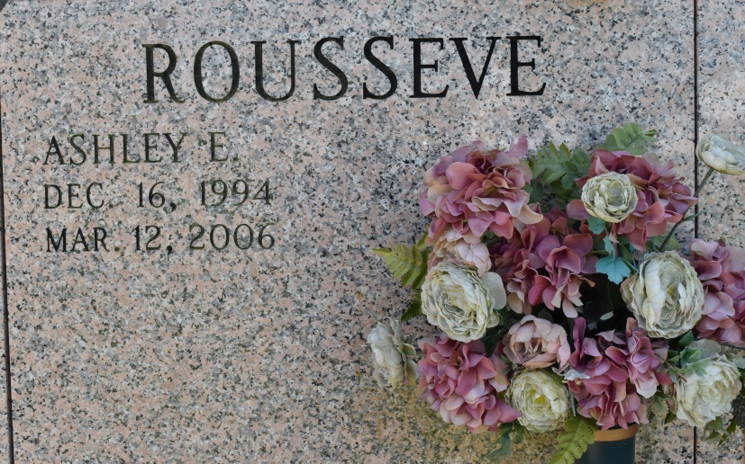

Ashley Elizabeth Rousseve of Vacherie, LA. on Sunday, March 12, 2006 at Thibodaux Regional Medical Center. Loving daughter of Helmuth Vital Rousseve III and Elizabeth Ann Grow Rousseve. Brother of Helmuth IV. Granddaughter of Florida Mae Grow, Elizabeth Rousseve, Priscilla Rousseve, Helmuth 'Duck' Rousseve, and the late John 'Dad' Grow. Also survived by a host of cousins, aunts, uncles, caretakers and friends. A native and resident of Vacherie, LA. Age 11 years. Ashley was a loving and affectionate child. She required at least 500 kisses and hugs a day, and love as much as food for survival. She was a little affection magnet.

Relatives and friends of the family, also Priest and parishioners of St. Phillip Catholic Church, New Creation Life Changing Ministries, St. James Catholic Church, Our Lady of Peace Catholic Church, Vacherie Elementary staff and student body and employees of Terreborne General Medical Center, Duck's Ice Inc. are invited to attend a Mass of Christian burial on Saturday, March 18, 2006 at 11:00 a.m. from the St. Phillip Catholic, Hwy. 18, Vacherie, LA. Father Louis Oubre, celebrant. Entombment church cemetery. Visitation at the church after 8:30 a.m. on Saturday. Recitation of Rosary 9:00 a.m. The Baloney Funeral Home, L.L.C. 399 Earl Baloney Dr., Garyville, LA. 70051 985-535-2540 In charge of arrangements.

Published by The Times-Picayune, New Orleans, LA from Mar. 15 to Mar. 17, 2006.