John B. Schexnayder, Jr.

AKA Yahya S. Muhammad

April 18, 1948 – July 20, 2011

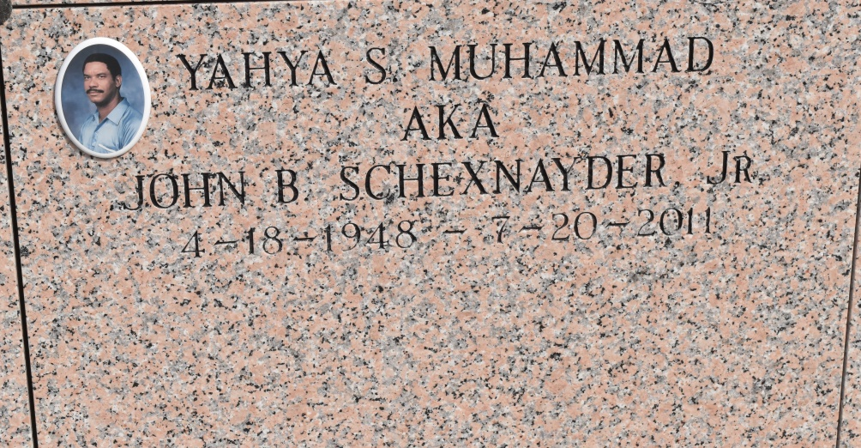

Yahya Salaam Muhammad a.k.a. John B. Schexnayder, Jr. on Wednesday, July 20, 2011 at Ochsner Hospital, Jefferson, LA. Son of Dolores Harris and John B. Schexnayder, Sr. Husband of Deborah F. Schexnayder. Father of Dwyer Muhammad (Natasha), Brandy Stewart (Benjamin III) and Renee Muhammad. Brother of Carol Ann, Wesley, and Theodore Schexnayder all of Vacherie, LA, Randall Schexnayder of Gretna, LA, Ricardo Schexnayder of Baton Rouge, LA, Laphalle Schexnayder of Biloxi, Mississippi, Dale Schexnayder of San Marcos, Texas, Acquanette Mitchell of Ruston, LA and the late Suzette Schexnayder. Also survived by 5 grandchildren and a host of nieces, nephews, other relatives and friends. Age 63 years. A native and resident of Vacherie, LA Relatives and friends of the family, also pastors, officers and members of Highway Baptist Church of Vacherie, Living Gospel of Houma and all neighboring churches, employees of Noranda Aluminum of Gramercy, LA, St. James Parish Human Resources, Ocean Behavioral Hospital, Lafourche Parish Public School System, Brand, and Office of Community Services are invited to attend the funeral at Highway Baptist Church, 1185 Magnolia Heights, Vacherie, LA on Monday, July 25, 2011 at 11:00 AM. Rev. Wesley Brown, Pastor, Rev. Reginald Glispy of Living Gospel, Houma, LA, Officiating. Interment St. Phillip Catholic Church Cemetery, Vacherie, LA. Visitation at the above named church from 9 :00 AM until service time. SERVICED BY ROBOTTOM

Published in The Times-Picayune, New Orleans, LA on July 24, 2011