Richard M. Schexnayder, Jr.

April 8, 1958 – May 14, 2009

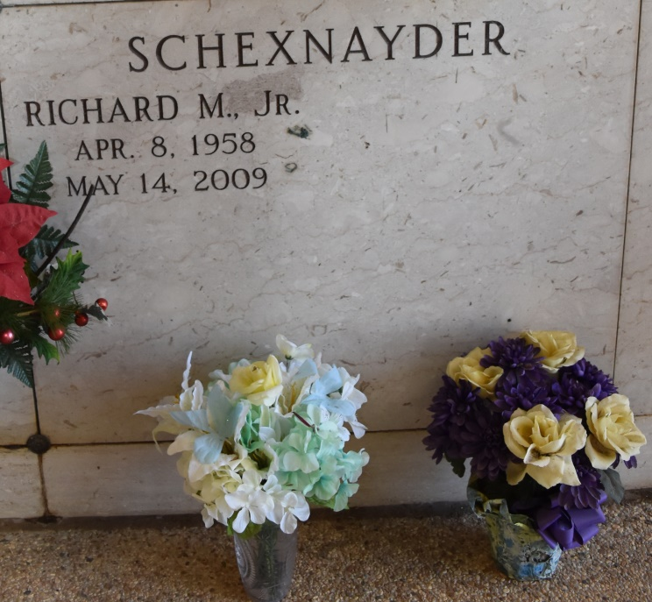

Richard M. Schexnayder, Jr., age 51 years, died on Thursday, May 14, 2009 in Vacherie, LA. Son of Shirley Loup and Richard M. Schexnayder, Sr. Brother of Michelle S. Champagne (Frankie), and Penny Schexnayder. Godfather of April Sellers and Laura Matherne. Uncle of Melissa and Blake Champagne and Andre Schexnayder. Also survived by four great nieces and one great nephew, former wife Luanna L. Schexnayder and special friends, Brenda Oubre and daughter Amber.  
 Richard was an avid motorcyclist and enjoyed camping, volleyball and barbequing for family and friends. He was a true lover of classic rock.  
 Special thanks to family and friends for all of their love, support and prayers.  
 Relatives and friends of the family are invited to attend a Funeral Mass on Tuesday, May 19, 2009 at 12:00 Noon from the Church of St. Philip in Vacherie, LA. Visitation on Tuesday from 9:30 AM until service time. Interment in the Church Cemetery. Masses preferred, in lieu of flowers. Arrangements by THARP-SONTHEIMER-THARP of Metairie.  
 Online guestbook may be signed at [www.legacy.com](http://www.legacy.com). Information: (504) 835-2341

Times-Picayune, The (New Orleans, LA) - Monday, May 18, 2009

Contributed by Jane Edson