Stanley Benedict Schexnydre

May 22, 1920 – June 12, 2010

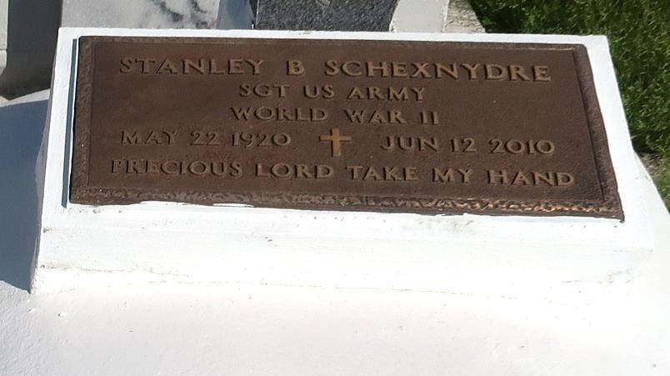

Stanley Benedict (Swatzi) Schexydre, a retired teacher and principal from St. James Parish Schools, died on Saturday, June 12, 2010 at Thibodaux Regional Medical Center. He was 90 years of age. A resident of St. James, LA, he previously lived in Trenton, Texas. Son of the late Arnold and Veronica Roussell Schexnayder. Husband of Edith B. Schexnydre. Former husband of Madeliene Phillip. Father of Mallory (Anne Marie) Schexnydre of St. James, LA, Merrell (Debbie) Schexnydre of El Dorado Hills, CA, Michael Dumas of Algiers, LA, Lionel Costley, Jr. of St. James, LA and Deltha (Charles) Whjte of Pflugerville, Texas. Brother of Leonard (Doris) Schexnayder of Lucy, La, John (J.B.) (Delores) Schexnayder of Vacherie, LA, Harvey James of Del Rio, CA, Rev. Adele Schexnayder of Vacherie, LA, the late Roland Hollis Schexnayder and Leona Adams. Survived by 17 grandchildren, 4 great-grandchildren, other relatives and friends.

Relatives, friends, former students, fellow eductors, and parishioners of St. James Catholic Church, and St. Phillip Catholic Church; employees of St. James Parish School Board, and Davita Dialysis Center are invited to attend a Mass of Christian Burial on Friday, June 18, 2010 at 11:00 a.m. from the St. James Catholic Church, St. James, LA. Father Mike Miceli, celebrant. Interment St. Philip Catholic Church Cemetery, Vacherie, LA. Visitation after 9:00 a.m. The Baloney Funeral Home, L.L.C. 399 Earl Baloney Dr., Garyville, LA Information: (985) 535-2540 In Charge of Arrangements

Published by The Times-Picayune, New Orleans, LA on Jun. 17, 2010.