Orabelle Faucheux Simon
August 2, 1927 - April 13, 2024

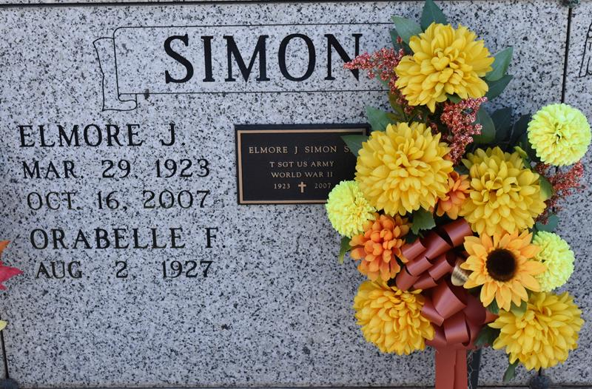

Orabelle Faucheux Simon passed away on Saturday, April 13, 2024 at the age of 96. She was born and a resident of Vacherie, LA.
Beloved wife of the late Elmore Joseph Simon, Sr. Loving mother of Elmore J. Simon, Jr. (Kathy), Leroy G. Simon and the late Charles J. Simon and Belle M. Tassin. Grandmother of Sheri M. Sison, Lori M. Templet, Charles Simon, Todd Simon, Jeremy Simon, Brandon Simon and Kristin O’Rourke. Daughter of the late Martha Marie Haas Faucheux and Ferducie J. Faucheux, Sr. Sister of George Faucheux (Louise) and the late Maria F. Simon (the late Nolan), Ferducie J. Faucheux, Jr. (the late Geraldine by first marriage and the late Solange by second marriage) and Paul Faucheux (Ouida). Also survived by 16 great-grandchildren and nieces and nephews.
Relatives and friends are invited to attend the Visitation and Funeral Mass at St. Philip Catholic Church, 1175 LA-18, Vacherie, LA on Friday, April 19, 2024. Visitation at church from 9:00 a.m. to 11:00 a.m. followed by a Funeral Mass at 11:00 a.m. Interment in St. Philip Church Cemetery, Vacherie, LA.

Rose Lynn Funeral Home, Lutcher, Louisiana
April 16, 2024

