Irma (Raphael) Smith

March 1, 1936 – March 17, 2006

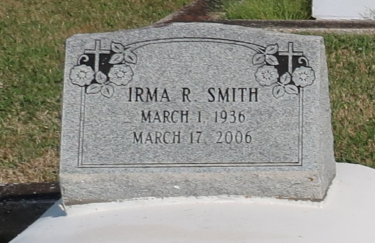

Irma Raphael Smith on Friday, March 17, 2006 at Audubon Guest House in Thibodaux, LA. Beloved daughter of the late Lazarus and Lucille Raphael. Former wife of Retired Master Sgt. Warren L. Smith of Benbrook, Texas. Loving sister of Brenda R. Mitchell (Leroy) of Edgard, LA, Andrew Raphael (Geraldine) of Lutcher, LA., Warren Raphael (Mary Jo) of Los Angeles, California and the late Joseph Daniel Raphael, Sr. (Geraldine Ross-Raphael White). Survived by a host of nieces, nephews, other relative and friends.

Relatives and family, also priest and parishioners of St. Phillip Catholic Church, St. John the Baptist Catholic Church, and employees of Thibodaux Regional Hospital, Audubon Guest House, and Vacherie Dialysis Center, are invited to attend a Mass of Christian Burial on Saturday, March 25, 2006 at 11:00 am at St. Phillip Catholic Church, Hwy 18, Vacherie, LA. Father Oubre, Celebrant. Visitation at the church after 9:00 am. Rosary at 10 am. Interment church cemetery. The Baloney Funeral Home, LLC 399 Earl Baloney Dr.-Garyville, LA. (985) 535-2540 In Charge of Arrangements

Published by The Times-Picayune, New Orleans, LA on Mar. 24, 2006.