Phillip Sorrell

July 12, 1947 – April 5, 2011

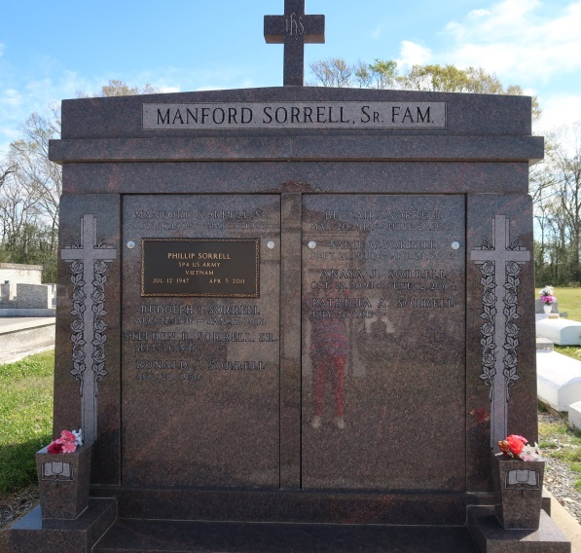

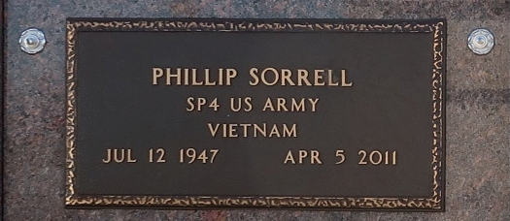

Phillip "Slim' Sorrell, age 63, departed this life on Tuesday, April 5, 2011, and entered into eternal rest. Son of the late Manford Sorrell, Sr. and Beulah Jasmine Sorrell. Beloved husband of Harriette Johnson Sorrell. Father of Shadona and Monya Sorrell of New Orleans, Louisiana, also Keenon Sorrell (Faith) of Hahnville, Louisiana. Grandfather of ten surviving grandchildren and the late granddaughter, Anaya Sorrell. Bother of Margaret Robinson, Stephen Sr. and Manford Sorrell, of New Orleans/Shreveport, Louisiana, Patricia, Ronald, and Rudolph Sorrel of Vacherie. Also survived by three godchildren, four aunts, one uncle, two sisters-in-law, seven brothers-in-law, nephews, relatives and friends, a host of nieces and devoted family friend, Freddie Pate. He was a Vietnam veteran of the United States Army Corporal E-4 and owner/operator of Sorrell Lawncare and Bobcat Services.

Relatives, friends of the family and employees of West Jefferson Hospital 3rd and 8th floors, Greater St. James Baptist Church and neighboring churches are invited to attend a Funeral Service at St. Bonaventure Catholic Church, 329 St. Jamie Blvd., Avondale, LA, on Monday, April 11th, 2011, at 10 o'clock AM, visitation will begin at 8:30 AM until time of service. A viewing will be held at the Baloney Funeral Home, LLC on Sunday, April 10th, 2011, from 2:00 PM to 4:00 PM, located at 399 Earl Baloney St., Garyville, LA, (985) 535-2540. Entombment will be in St Phillip Catholic Church Cemetery, Hwy. 18, Vacherie, LA. Arrangements by The Baloney Funeral Home, guest may sign the register at: [www.baloneyfuneralhome.com](http://www.baloneyfuneralhome.com/)

Published by The Times-Picayune, New Orleans, LA on Apr. 10, 2011.