Rudolph J. Sorrell

August 27, 1936 – January 17, 2018

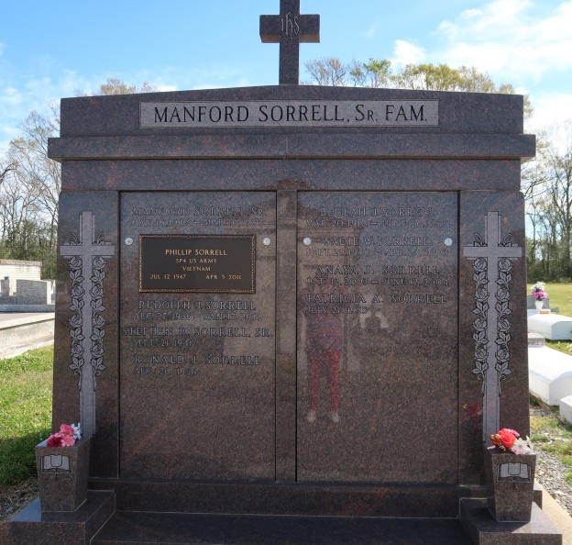

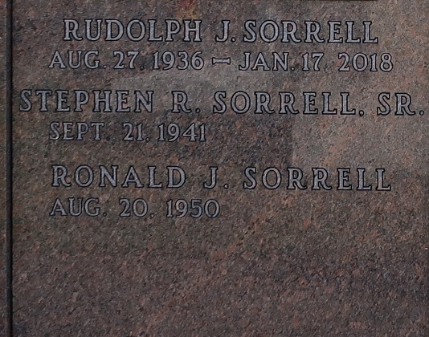

Rudolph "Rudy" Sorrell, age 81, departed this life on Wednesday, January 17, 2018 and entered eternal life. Son of the late Manford Sorrell Sr. and Beulah Jasmin Sorrell. Beloved husband of the late Florida Turner Sorrell. Brother of Margaret Robinson and Stephen Sorrell, Jr. of New Orleans, LA, Manfard Sorrell Jr. of Slidell, LA, Patricia and Ronald Sorrell of Vacherie, LA. Also survived by two aunts, one brother-in-law, two sisters-in-law, nieces, nephews, relatives and friends.

Relatives and friends of the family, Local Union 689 of New Orleans, LA are invited to attend a Mass of Christian Burial on Tuesday, January 23, 2018 from St. James Catholic Church, 6613 Hwy 18, St. James, LA. Visitation begins at 9:00am followed by service at 11:00AM. Father Matthew McCaughey, Celebrant. Entombment St. Philip Catholic Church Cemetery, Hwy 18, Vacherie, LA. Treasures of Life Funeral Services have been entrusted with his final care- 315 E. Airline Hwy, Gramercy, LA 70052

Published by The Times-Picayune, New Orleans, LA from Jan. 19 to Jan. 24, 2018.