Rayally Joseph Steib

July 20, 1939 – February 3, 2020

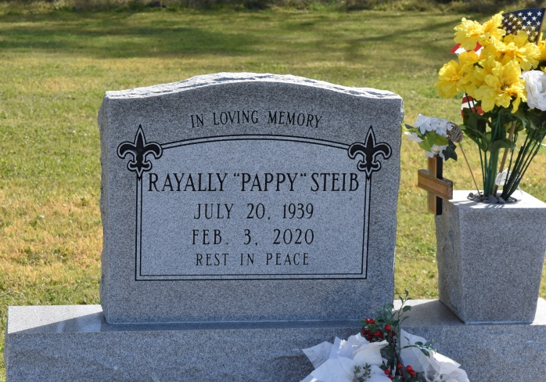

Rayally Joseph Steib, a native of Vacherie and a resident of LaPlace, passed away at 11:10 a.m., Monday, February 3, 2020 at Twin Oaks Nursing Home in LaPlace. He was 80. Viewing at Our Lady of Peace Catholic Church, Vacherie, Tuesday, February 11, 2020 from 9:00 a.m.until Mass of Christian Burial at 11:00a.m. Interment in St. Phillip Catholic Church cemetery in Vacherie.

Survived by sisters: Mary (Alton, Sr.) Long, Cynthia (Alfred) Joseph, Donna (Charles) Love, Nadine (Herman) Lewis, Darlene Mayho and Mary Hughes. Brothers: Ronald (Celestine) Steib, Nelson, Jr., (Rita) Steib, James (Shelia) Steib, Ronnie Paul (Wanda) Steib and Michael Steib. Also numerous aunts, uncles, nieces, nephews, cousins other relatives and friends. Preceded in death by his parents: Nelson Steib, Sr. and Rosemary Jeffery Steib. A brother: Alvin Steib. Sisters: Ruby Weber and Diane Singleton. A Brother-in-law: Phillip Hughes.

Brazier-Watson Funeral Home in charge of arrangements. Visit us at [www.brazierwatson.com](http://www.brazierwatson.com/) to sign our guest book.

Published by The Advocate, Baton Rouge, LA from Feb. 9 to Feb. 11, 2020.