Mary Victoria (Etienne) Stewart
August 1, 1942 – March 27, 2025

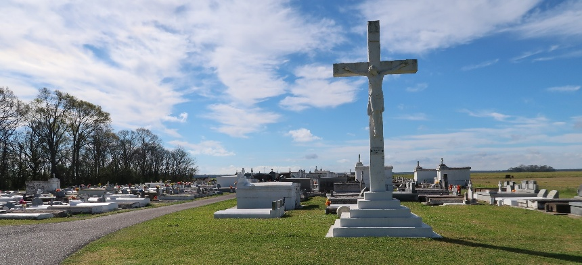

Mary Victoria Etienne was born on August 1, 1942, in Vacherie, LA. She was the eldest of nine children born to the late Irvin T. and Mildred Noel Etienne. On March 27, 2025, at the age of 82, she passed away peacefully at home. Those fortunate enough to know and love Mary would describe her as bold, compassionate, benevolent, confident, generous, and deeply rooted in her faith. She fully embraced her role as the eldest sibling, taking great pride in being someone her family could look up to.
Mary graduated as Salutatorian of Magnolia High School’s Class of 1960 before earning a Bachelor's in Education from Southern University in Baton Rouge. She returned to Magnolia High School following graduation as a teacher. It was her teacher’s salary that allowed her to purchase a larger home for her parents and younger siblings—a gesture of love and responsibility she cherished deeply. It was one of the things she was most proud of. Little did she know, that house would be a place where the Etienne family would gather and start family traditions that we still honor to this day.
Committed to lifelong learning, Mary earned a Master’s Plus 30 degree from the University of New Orleans. Over the years, she served as a teacher at L.B. Landry High, a counselor at John McDonogh High, and ultimately retired in 1998 as the principal of William Franz Elementary in New Orleans after 34 years of dedicated service. Teaching was her calling, and she never missed an opportunity to learn, educate and uplift others.
On December 27, 1966, Mary married Pleasant Stewart, Jr., following a high school courtship. Their 58-year union was a testament to love, mutual respect, and unwavering devotion. Together, they enjoyed traveling, serving in various ministries at their church, and hosting their nieces and nephews over the summer.
Mary’s faith was the foundation of her life. Baptized as a young woman at Morning Star Baptist Church in Marrero, LA, she later became a devoted member of Star of Bethel Missionary Baptist Church in New Orleans for over 40 years. She served as financial secretary, usher, and played a key role in organizing annual Black History programs, church anniversaries, and the Feed the Hungry Ministry. After nearly four decades in New Orleans, she and Pleasant relocated to Gramercy, LA, following Hurricane Katrina.
A creative spirit, Mary found joy in crafting, designing beautiful floral arrangements and wreaths, and working with stained glass—installing her handcrafted windows in her New Orleans home and Star of Bethel Church. She was an avid collector of Black dolls, Black angels, and memorabilia. She also loved shopping and traveling the world with her sisters, nieces, and best friends, Bertha Irons and Barbara Duhe. Calling themselves “The Golden Girls,” the trio never let an ocean or a long road trip stand in the way of their adventures and laughter.
Above all, Mary cherished her family. As the matriarch of the Etienne family, she upheld traditions, ensuring Thanksgiving at noon was always a time of prayer, fellowship, and togetherness. She provided steadfast support—both emotional and financial—to her loved ones, guiding them with wisdom, tough love, and an open heart. Though she never had biological children, she mothered and nurtured many in her special way, offering counsel, mediation, motivation, and unwavering love. Known as the “Boss Lady,” she made difficult decisions when needed, but her intentions were always rooted in unconditional love.
In her later years, Mary found joy in genealogy, reconnecting with relatives across Illinois, Georgia, New Orleans, and St. Francisville. She never missed an opportunity to reflect on her childhood and the Vacherie community, ensuring that we always remembered our roots and the people who anchored our legacy. Dedicated to preserving her family’s history, she proudly donated heirlooms to the descendants’ exhibit at Laura Plantation.
Mary leaves to mourn her passing and cherish precious memories: her loving and devoted husband, Pleasant Stewart, Jr.; bonus son, Don Davis; sisters Linda Rixner, Mildred Etienne, Vondra Steib (Richard); brother August (Catherine) Etienne; brother-in-law Thomas Joseph, Jr.; uncle Percy Noel; godchildren Marsha Brown Fleming, Carla Garrett Philip, and Oliver Hooker, Jr.; and many nieces, nephews, cousins. She will also be deeply missed by dear friends Bertha Irons, Barbara Duhe, and Delores Scieneaux. She was preceded in death by her parents, Irvin and Mildred Etienne; her maternal grandparents, Ambrose and Mary McNair Noel; her paternal grandparents, August and Victoria Charles Etienne; and her siblings, Rita E. Johnson, Brenda E. Trench, Faye E. Hooker, and Lorenza E. Joseph. Mary’s legacy of love, service, and faith will forever remain in the hearts of those who knew her.
A public gathering of family and friends will be held on Friday, April 4, 2025 from 5:00pm to 7:00pm at Treasures of Life Funeral Services, 315 E. Airline Hwy., Gramercy, LA 70052. A celebration honoring her life and legacy will be held on Saturday, April 5, 2025, at First Baptist Church, 1244 Magnolia Heights St., Vacherie, LA for 11 A.M. Visitation begins at 9 A.M. Entombment to follow at St. Philip Catholic Church Mausoleum, Vacherie, LA.

Treasures of Life Funeral Services, Gramercy, Louisiana
April 6, 2025

