Albert Joseph Waguespack, Sr.

November 8, 1930 – November 10, 2000

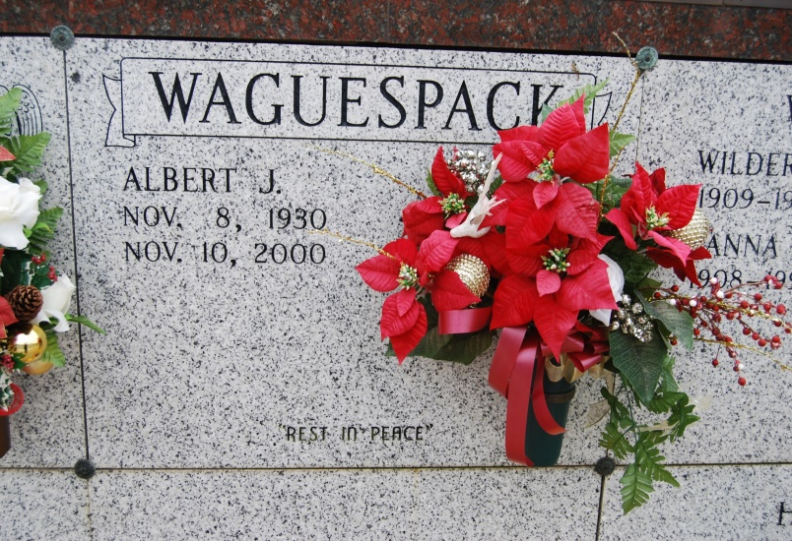

Photo by Kerry Keller

Albert Joseph Waguespack Sr. - Owner of Waguespack Oil Co. and a native and resident of Vacherie, he died at 9 a.m. Friday, Nov. 10, 2000. He was the beloved husband of Jackie Gravois Waguespack; father and father-in-law of Christine and Bill Cranford of Lafayette, Ellie and Carl Sandlin of Thibodaux, Julie and Ron Barry of Brandon, Miss., Al and Cindy Waguespack, Michael and Jill Waguespack, and Eric J. Waguespack, all of Thibodaux; and survived by 17 grandchildren. He was the son of Cecile Schexnayder and the late FrancisA. Waguespack; adopted son of the late Leonard M. and Maude G. Waguespack; brother of Shirley Waguespack, Mary Ann Borne, Cecile Hymel, Elaine Legendre and Geraldine Waguespack, all of Vacherie, Barbara Wood of St. James, Francis A. Waguespack Jr., Thomas Waguespack, Charles Waguespack and Wayne Waguespack of Vacherie and the late Allen M. Waguespack. He was a member of Knights of Columbus Council 1514 for more than 50 years and board of directors of First American Bank. Friends may call at St. Phillip Catholic Church, Vacherie, from 6 p.m. to 9 p.m. Sunday and after 8 a.m. Monday. Relatives and friends of the family are invited to attend Mass of Christian Burial to be celebrated at the church at 11 a.m. Monday. Entombment in church mausoleum.H.C. Alexander Funeral Home, Lutcher, in charge of arrangements.

Advocate, The (Baton Rouge, LA) - Saturday, November 11, 2000