Blanche (Haydel) Waguespack

1898 – July 31, 1990

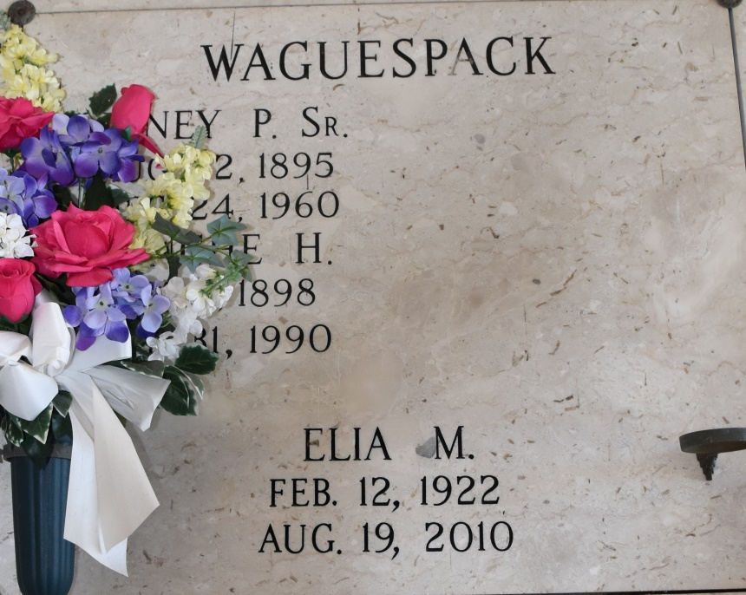

Blanche (Haydel) Waguespack

Funeral services will be at 1 p.m. Thursday at St. Philip Catholic Church in

Vacherie for Blanche Haydel Waguespack, a native and resident of Vacherie, who died Tuesday. She was 92. Visitation is at the church from 8 a.m. until funeral time Thursday. Entombment is in the church mausoleum.

She was the mother of Elia Marie Waguespack, Gaynell Bourgeois, Marcelle Haydel, Jewell Cuccia, Blanche Troxclair and Haydel A. Waguespack and sister of Martha H. and Hilda H. Waguespack and Florian Haydel. She is also survived by 28 grandchildren and 30 great grandchildren.

She was preceded in death by her husband, Sidney Waguespack Sr.; son, Sidney Waguespack Jr.; parents, Mr. and Mrs. Stephen Haydel Sr.; sisters, Georgine Haydel, Rose H. Rome and Marie H. Brou; brothers, Stephen and Albert Haydel and two grandchildren.

The Lafourche Daily Comet, Lafourche Parish, LA; Jul 31 1990

Contributed by Chris Tidwell