Catherine Louise (Simon) Waguespack

September 15, 1859 – October 26, 1955

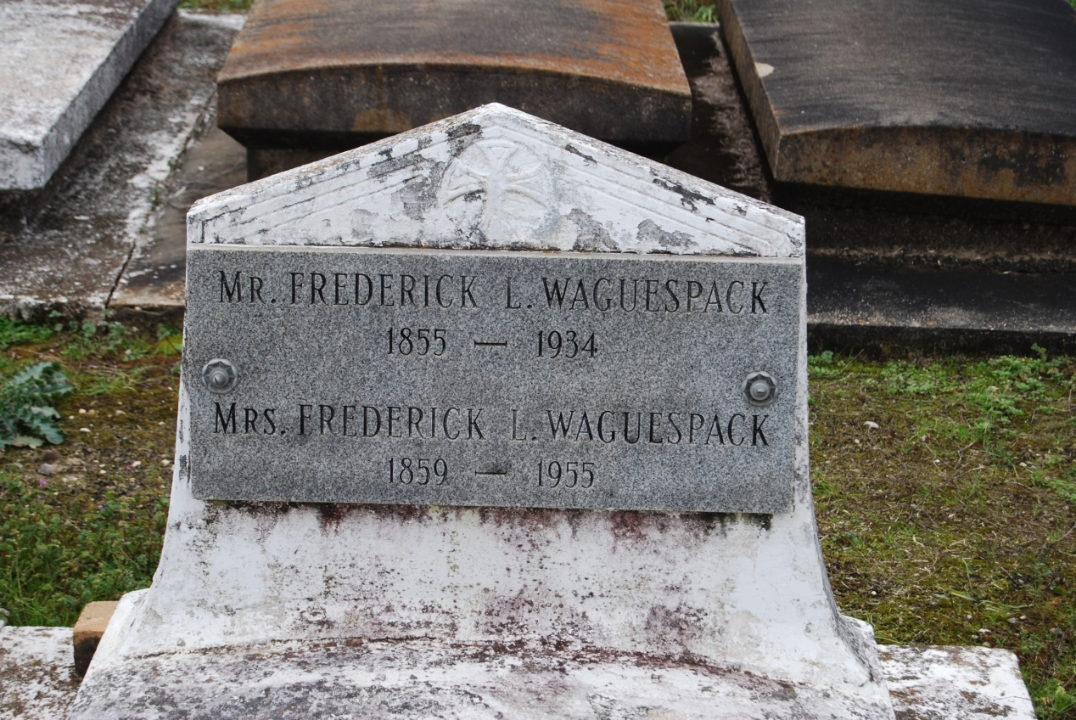

Photo by Kerry Keller

**WAGUESPACK** - In Wallace, La., on Wednesday, October 26, 1955, at 8 o'clock a.m., CATHERINE LOUISE SIMON, wife of the late Frederick Waguespack, mother of Mrs. Charles Barbier; Mrs. Marius Roussel; Mrs. Frank Tregre; Mrs. Ulysse Dufresne; Mrs. Joseph Dufresne; Mrs. Henry Hymel; Mrs. Z.A. Carlson, Louise and Henrietta Waguespack, also survived by 49 grandchildren; 118 Great Grandchildren and 42 Great Great Grandchildren; age 96 years. Relatives and friends of the family are invited to attend the funeral which will take place from the late residence in Wallace, La., on Friday, October 28, 1955 at 9 o'clock a.m., followed by religious services at St. Philip's church, Vacherie, La. Interment in St. Philip's Cemetery, Vacherie, La. Arrangements by Alexander Funeral Home, Lutcher, La.

Unknown source

Contributed by Kerry Keller