Claire B. Waguespack

April 15, 1912 – March 27, 2006

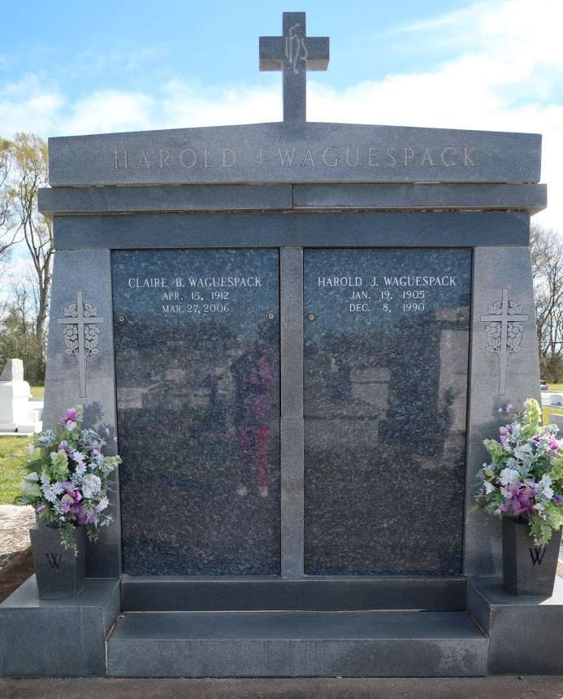

CLAIRE BOLTON WAGUESPACK

A resident and native of Vacherie, she died at 10:45 a.m. Monday, March 27, 2006. She was 93, born April 15, 1912. Visitation at First United Methodist Church, Thibodaux, from 9 a.m. Wednesday, March 29, until religious service at 11 a.m. Interment in St. Phillip Catholic Church Cemetery, Vacherie. She is survived by a brother, James M. Bolton; sister, Ruth B. White; and numerous nieces and nephews. Preceded in death by her husband, Harold J. Waguespack; mother and father, Willie Neal Bolton and Dr. William F. Bolton; two brothers, F. Neal Bolton and William "Bill" Bolton; and two sisters, Mabel B. Scotto and Dorothy B. Woltz. In lieu of flowers, please make donations to Hospice of South Louisiana or Vacherie United Methodist Church. Arrangements by Landry's Funeral Home, Thibodaux.

Published by The Advocate, Baton Rouge, LA on Mar. 28, 2006.