Claude Waguespack, Jr.

October 17, 1930 – November 28, 2010

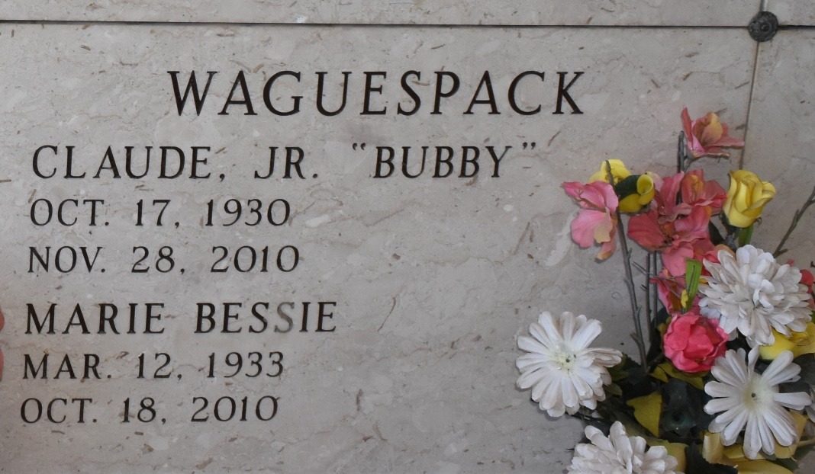

Claude "Bubby" Waguespack, 80, was born Oct. 17, 1930, and passed away Sunday, Nov. 28, 2010. He was a native of New Orleans and a resident of Vacherie.

He is survived by a daughter, Donna W. Borgognoni and a son-in-law, Reno M. Borgognoni; two grandchildren, Reno M. Borgognoni Jr., and Kristen Borgognoni; and two sisters, Joan W. Barre and Lelia W. Schexnayder.

He was preceded in death by his wife, Marie "Bessie" Matherne Waguespack; his son, Gordon J. Waguespack; his sister, Eva Mae W. Birch; and his parents, Eva B. and Claude Waguespack Sr.

Visitation will be at St. Philip Catholic Church, Vacherie, on Saturday, Dec. 4, from 9 a.m. until a Mass of Christian Burial at 11 a.m., with the Rev. Vincent Dufresne, celebrant. Burial in St. Philip Church Cemetery. Rose Lynn Funeral Services of Lutcher is in charge of the arrangements. To sign and view the family guestbook, please visit [www.roselynnfuneralhome.com](http://www.roselynnfuneralhome.com/).

Published by The Advocate, Baton Rouge, LA on Dec. 3, 2010.