Eva Marie (Becnel) Waguespack

October 19, 1905 – March 10, 2004

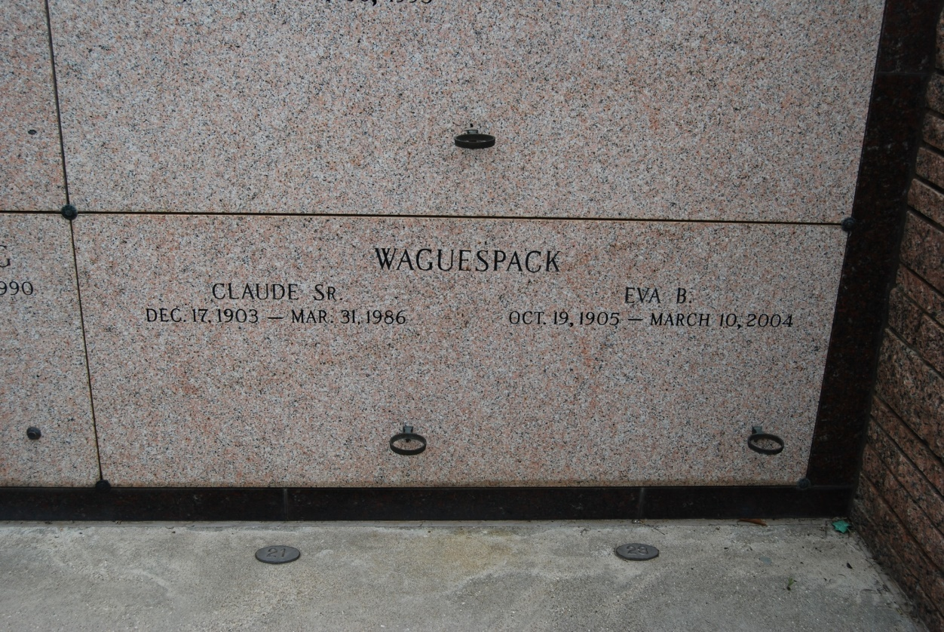

Photo by Kerry Keller

Eva Becnel Waguespack, on March 10, 2004 at D'Ville House Nursing Home in Donaldsonville, LA. She was 98 years old. Mrs. Waguespack was born in Edgard, LA and lived in St. Rose, Killona and New Orleans before moving to Vacherie, LA, 65 years ago. She, along with her husband, Claude Waguespack, Sr. owned St. Philip Confectionary in Vacherie. After his death in 1986, she continued to operate the business until finally retiring at age 92. Mrs. Eva, as she was called, loved to meet the many visitors from around the world who stopped in her store on their way to visit the local river road plantation homes. She often conversed in French with the tourists, sharing local customs and history of her beloved community. Mrs. Eva was a member of St. Philip Catholic Church in Vacherie. She was a Charter Member of the Catholic Daughters of America, Court St. Philip No. 1504. Survivors include: daughters: Lelia Schexnayder, Joan Barre'; son, Claude (Bubby) Waguespack, Jr.; daughter-in-law, Bessie Waguespack; son-in-law, Wesley Burch; ten grandchildren, 14 great grandchildren, three great-great grandchildren; and a host of nieces and nephews. She was preceded in death by: siblings: Ada Vicknair, Denise Becnel, Noelie Ayo and Albin Becnel; daughter, Eva Mae Burch; sons-in-law: Felecien P. Schexnayder, Carl A. Barre'; and grandson, Gordon Waguespack. Mrs. Waguespack was the daughter of the late St. Martin and Clara Landeche Becnel. A Funeral Mass of Christian Burial will be held at St. Philip Catholic Church in Vacherie, LA on Saturday, March 13, 2004 at 11:00 AM. Visitation will be at the church from 9:00 AM until funeral time. Interment will be in the St. Philip Church mausoleum. In lieu of flowers, MASSES are preferred. ALEXANDER FUNERAL HOME, Lutcher, LA is in charge of the arrangements.

Times-Picayune, The (New Orleans, LA)

Thursday, March 11, 2004