Francis Anthony Waguespack, Jr.

June 5, 1926 – September 4, 2011

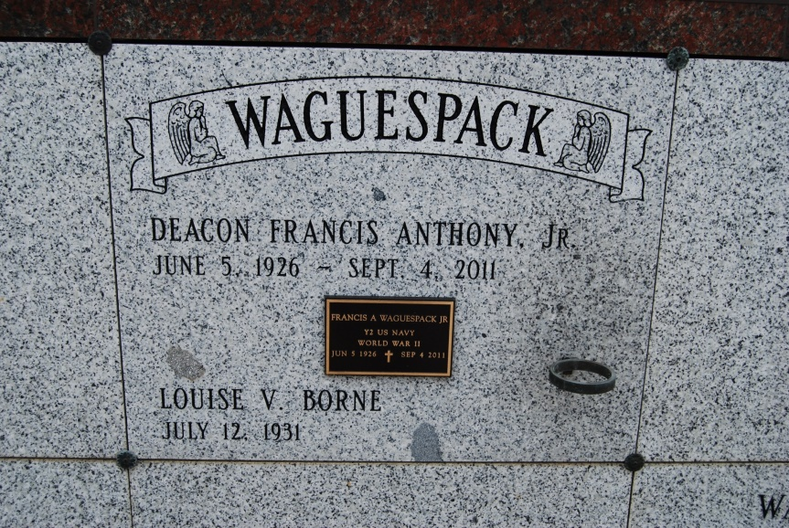

Photo by Kerry Keller

Deacon Francis Anthony Waguespack, Jr. died at his home on Sunday, September 4, 2011 at 10:38AM He was 85 years old. He is survived by his loving and devoted wife of 59 years Louise Borne Waguespack/  
 Father and father-in-law of Anne W and Wayne Rodrigue of Vacherie, Francine W and Greg Gillespie , Francis III and Debra Waguespack, and Carolyn W and Lynn Graugnard all of Thibodaux and Clinton Paul and Tonya Waguespack of St Amant, LA. Grandfather of Joey (Tricia) Rodrigue, Lee R (Tyson) Panvelle, Brian (Sarah) Rodrigue, Caroline G (Greg) LeBlanc, Will and Michele Graugnard, Francis IV , Shelley (Steven) Gros, Teran Gilmore, and Tj Westbrook. Great grandfather of Adele and Ty Panvelle, Cy Rodrigue and Cameron Barry Rodrigue, Bryce and Caleb Glimore.  
 Francis was the eldest of 12 children born to the late Francis and Cecile Schexnayder Waguespack. Brother of MaryAnn Borne, Cecile Hymel, Elaine Legendre, Geraldine Waguespack, of Vacherie and Barbara Wood of St James, Thomas Waguespack, Charles Waguespack and Wayne Waguespack of Vacherie.  
 Preceded in death by brothers Albert Waguespack and Allen Waguespack , sister Shirley Waguespack and granddaughter Beth Anne Rodrigue. A native and resident of Vacherie, Francis was President of Vacherie Mart, Inc., a member of the Fourth Degree Knights of Columbus, and a board member of First American Bank and Trust. He also served in the United States Navy during WW II. Francis was the first Ordained Permanent Deacon for the Diocese of Baton Rouge in 1976.  
 Mass of Christian Burial at St Phillip Catholic Church on Wednesday, September 7, 2011 at 12:00 noon with Father Vincent Dufrense officiating. Burial will follow in St Philip Mausoleum. Visitation will be held from 8 am until funeral time. In lieu of flowers, memorials may be sent to Diocease of Baton Rouge for establishment of a Seminary Scholarship Fund in Deacon Francis's name.  
 Arrangements under the direction of H.C. Alexander Funeral Home, Lutcher, LA. Family and friends are invited to send their condolences to [www.hcalexanderfh.com](http://www.hcalexanderfh.com).

Times-Picayune, The (New Orleans, LA) - Tuesday, September 6, 2011

Contributed by Jane Edson