George Henry Waguespack, Sr.

July 30, 1926 – October 17, 2001

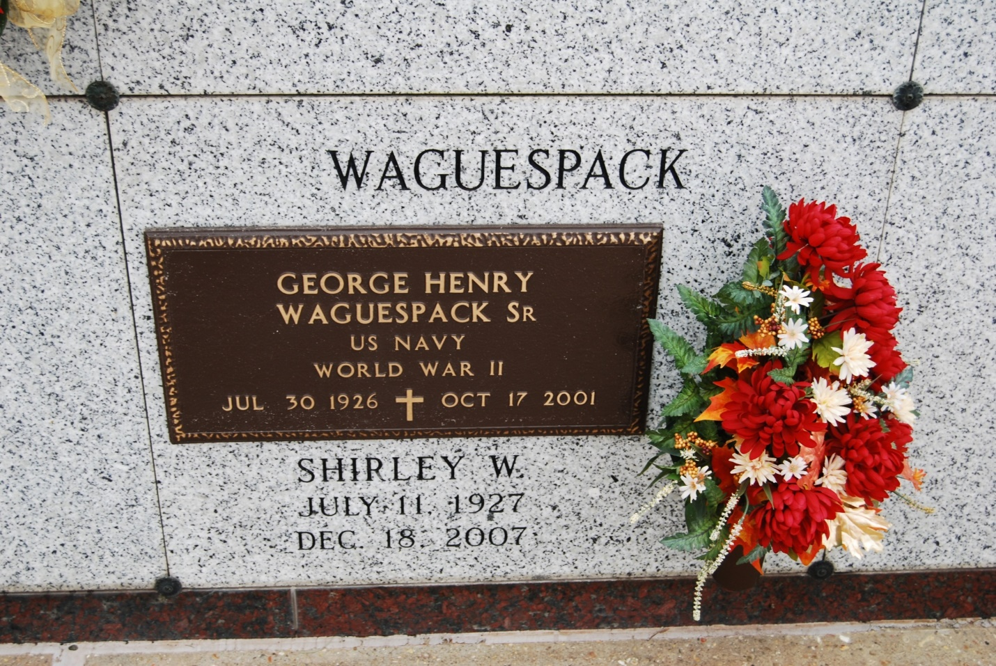

Photo by Kerry Keller

Waguespack, George H. Sr. - Died on Wednesday, Oct. 17, 2001, at 4 a.m. He was the beloved husband of Shirley W. Waguespack. Father and father-in-law of Shirley W. and Lee Granier of Vacherie, George H. Jr. and Mary Waguespack of Austin, Texas, Carroll J. and June Waguespack and Glenn M. and Lona Waguespack, all of Vacherie, Barry J. and Valerie Waguespack of Thibodaux, Patrick G. and Denise Waguespack of Vacherie, and Randal M. and Melinda Waguespack of Vacherie. Also survived by 20 grandchildren and two great-grandchildren. He was the son of the late Adam T. Waguespack Sr. and Myrthee Simon Waguespack; brother of Donald Waguespack of Jefferson, Adam Waguespack of Vacherie, Lloyd Waguespack of Houston, Lester Waguespack of Bayou Vista, and Clifford Waguespack of Vacherie. He was 75 and a native and resident of Vacherie. He was a U.S. Navy veteran of World War II. He was a member of Vacherie Veteran of Foreign Wars Post 04245 and Knights of Columbus Council 1514. He served as a Eucharistic minister at St. Phillip Catholic Church. Relatives and friends of the family are invited to attend the funeral services. A Mass of Christian Burial, celebrated by the Rev. Clarence Waguespack, will be celebrated on Saturday, Oct. 20, 2001, at 11 a.m. at St. Phillip Catholic Church in Vacherie. Friends may call at the church after 8 a.m. Saturday. Entombment in St. Phillip Mausoleum. Arrangements are entrusted to H.C. Alexander Funeral Home of Lutcher.

Advocate, The (Baton Rouge, LA)

Thursday, October 18, 2001