Juliette (Cazenave) Waguespack

October 28, 1912 – December 14, 2011

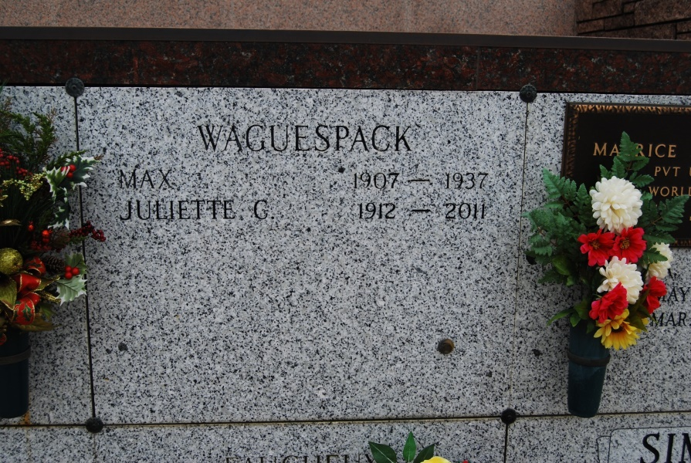

Photo by Kerry Keller

Juliette Cazenave Waguespack on Wednesday, December 14, 2011. Age 99 years. Beloved wife of the late Maxime A. Waguespack. Mother of Rosemary W. Haydel (Walter) of Metairie, LA, Lucille (Teeley) W. St Romain (Frank) of Mandeville, LA, Maxime (Mackie) Waguespack of Vacherie, LA, and the late Gloria Waguespack. Sister of E. V. Cazenave of Vacherie, LA and the late Roland (Bud) Cazenave, Sr of Vacherie, LA, Laurence C. Tregre of Vacherie, LA, Marie C. Chabaud of Wallace, LA and Louise C. Champagne of Luling, LA. Daughter of the late Etienne V. and Elena H. Cazenave.

She is also survived by 3 Grandchildren and 10 Great Grandchildren. Relatives and friends of the family, also members of the Ladies Altar Society and Catholic Daughters of America are invited to attend the visitation at St. Philip Catholic Church, 1175 Hwy 18, Vacherie, LA on Friday, December 16, 2011 from 8:30 AM until 11:00 AM. The Funeral Mass will be celebrated at 11:00 AM. Burial will be in St. Philip Cemetery, Vacherie, LA.   
 In lieu of flowers, enrollment of masses preferred. Arrangements under the direction of H. C. Alexander Funeral Home, Lutcher, LA. Condolences may be offered at [www.hcalexanderfh.com](http://www.hcalexanderfh.com)

Times-Picayune, The (New Orleans, LA)

Thursday, December 15, 2011