Mae Faucheux Waguespack

May 29, 1929 - January 01, 2022

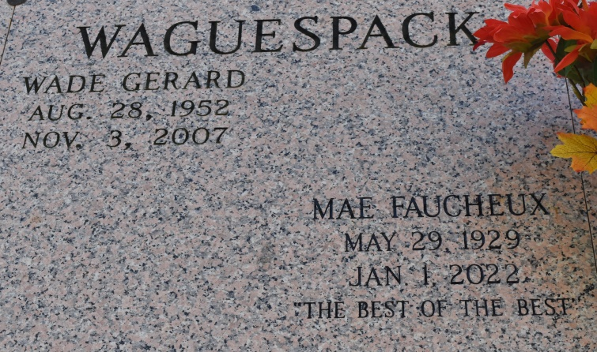

Mae Faucheux Waguespack, 92, went peacefully to our Lord Jesus on Saturday January 1, 2022. She was born in Wallace, LA on May 29, 1929. She was a native of Wallace and a long time resident of Gretna and Vacherie and a current resident of St. Anthony’s Gardens in Covington, LA for the past 5 years.

Mae earned a business degree in New Orleans and worked as a secretary for the Louisiana Welfare department and Rehabilitation Services until her retirement. She was an active member of her Church parishes at St Cletus Church in Gretna and at St Philip Church in Vacherie, serving as a Eucharistic Minister and singing in the choir. She also enjoyed serving as a lector at Masses at St. Anthony’s Gardens. She was a member and secretary for the Catholic Daughters of America. Mae had the heart of a servant. She was faithful, humble and kind.  
 She is survived by her loving husband of 70 years, Nolan Waguespack, Sr.; her children, Nolan Waguespack, Jr. (Teresa), Julie Poirier (David), Glenn Waguespack (Susan), Mary Marino (Lance), and Lisa Guillot (Lloyd); grandchildren, Kim, Hanna Joelle, Luke, Jacquelyn, Jonathan, Daniel, Matthew, Joseph, Sarah, Sam, Jacob, Elena, Rachel, Dominic, Mallory, Monica, Lloyd Joseph, Christopher and Nathan; 11 great grandchildren and numerous nieces and nephews.

She was preceded in death by her son, Wade Waguespack; parents, Sidney Gabriel & Julie Cazenave Faucheux; brother, Sidney Faucheux; and sister Martha Hymel.  
 The family would like to give special thanks to the following for caring for their mother in her final days: St. Anthony’s Gardens staff, Compassus Hospice, and Life’s Precious Jewels sitting service, especially Kim.  
 Relatives and friends are invited to attend visitation at St. Philip Catholic Church, Vacherie, LA. on Saturday, January 8, 2022 from 9-11 am followed by A Mass of Christian Burial.  Interment to follow at St. Philip Cemetery & Mausoleum. We ask that all those who attend services to please wear a mask.

Rose Lynn Funeral Home, Lutcher, Louisiana

February 25, 2022