Marie Bessie (Matherne) Waguespack

March 12, 1933 – October 18, 2010

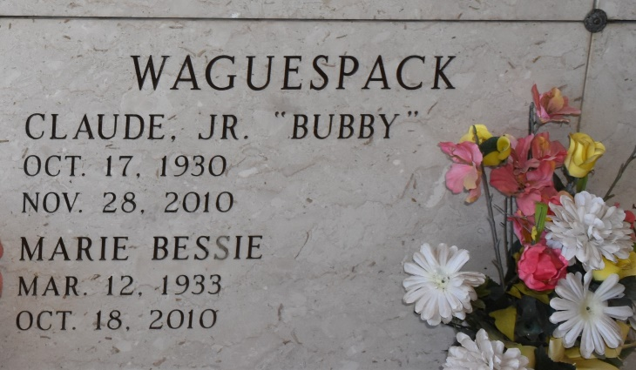

Marie "Bessie" Matherne Waguespack, 77, was born March 12, 1933. She passed away Monday, Oct. 18, 2010, in Lutcher. She was a native of St. James and a resident of Vacherie.

She is survived by her husband, Claude "Bubby" Waguespack Jr.; a daughter, Donna W. Borgognoni and husband Reno M. Borgognoni, of Lawrenceville, Ga.; and a brother, Lois J. Matherne and wife Mary. She is also survived by her grandchildren, Reno Mark Borgognoni Jr. and Kristen Borgognoni; two sisters-in-law, Lelia W. Schexnayder and Joan W. Barré; as well as a host of nieces and nephews.

She was preceded in death by her parents, Ruth H. and André Matherne; son, Gordon J. Waguespack; mother-in-law and father-in-law, Eva B. and Claude Waguespack Sr.; a brother, André Matherne; and sisters, Loretta Kramer, Hazel Gauthreaux and Florence Dufresne.

Visitation will be at St. Philip Catholic Church in Vacherie on Saturday, Oct. 23, from 9 a.m. until 11 a.m. with the rosary at 9:30 a.m. recited by the Catholic Daughters. A Mass of Christian Burial will follow at 11 a.m. with the Rev. Vincent Dufresne, celebrant. Entombment in St. Philip Church Mausoleum. Arrangements by Rose Lynn Funeral Services, 1870 Cabanose Ave., Lutcher. To sign and view the family guestbook, please visit [www.roselynnfuneralhome.com](http://www.roselynnfuneralhome.com/).

Published by The Advocate, Baton Rouge, LA on Oct. 21, 2010.