Ronald Joseph Waguespack Sr.

March 24, 1933 – April 18, 2005

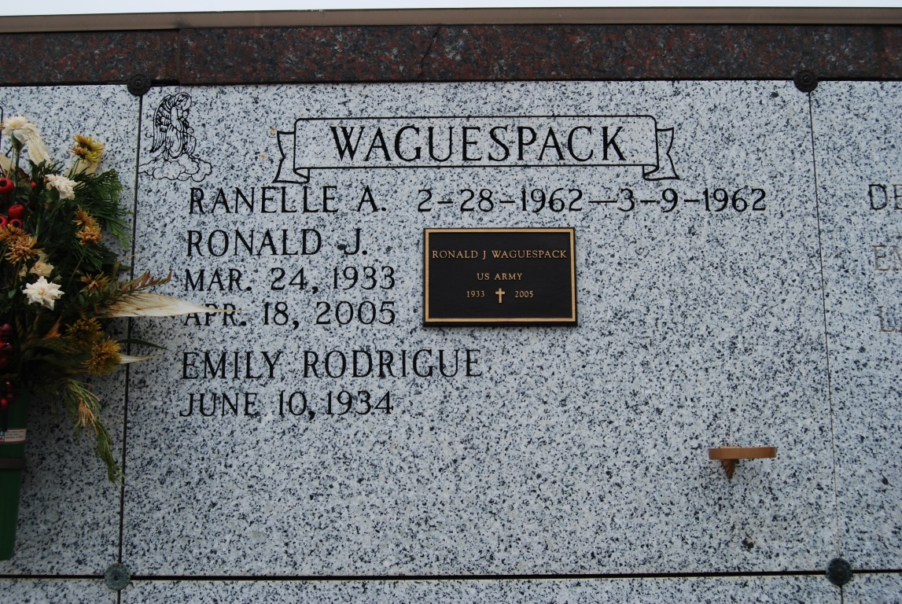

Photo by Kerry Keller

Ronald Joseph Waguespack Sr., a native and resident of Vacherie, died Monday, April 18, 2005, at the age of 72. He is survived by his loving wife of 49 years, Emily Rodrigue Waguespack; daughters and sons-in-law, Rhonda and William Morvant, Baton Rouge, Ramona and Joseph Whitman, Thibodaux, and Reina and Richard Steele, Waynesville, N.C.; sons and daughters-in-law, Ronald Jr. and Phyllis of Thibodaux, Randy and Melynda of Moorehaven, Fla., and Robby and Jamie of Covington; siblings, Mrs. Arnold (Laura Lee) Schexnayder, Mrs. Roland (Lily) Perque of Vacherie and Warren Waguespack of Houma; 15 grandchildren, Brian, Emily and Eric Morvant, Marcel, Katelyn, Kayla and Kristen Waguespack, Paul and Adrienne Whitman, Therese "Tess" and Annalise Steele, William, Grace and John Hayes Waguespack and Nicole Mathis; and a great-grandchild. He was preceded in death by his son, Ranelle A. Waguespack; and parents, James and Yvonne Folse Waguespack. He was a member of the Knights of Columbus Council 1514, an extraordinary minister of the Eucharist and an usher for St. Philip Catholic Church. He retired as a supervisor for Monsanto Chemical Co., where he was employed for 39 years. He also served in the U.S. Army and was an avid deer hunter.

Visitation at St. Philip Catholic Church from 8 a.m. Thursday, April 21, until Mass of Christian Burial at 11 a.m., celebrated by the Rev. Clarence Waguespack. Entombment in St. Philip Mausoleum. H.C. Alexander Funeral Home, Lutcher, is in charge of arrangements. Donations may be made to Parkinson's Association of Louisiana, P.O. Box 10303, New Orleans, LA 70181.

The Advocate (Baton Rouge, LA)

April 20, 2005