Shirley Philomene (Waguespack) Waguespack

June 11, 1927 – December 18, 2007

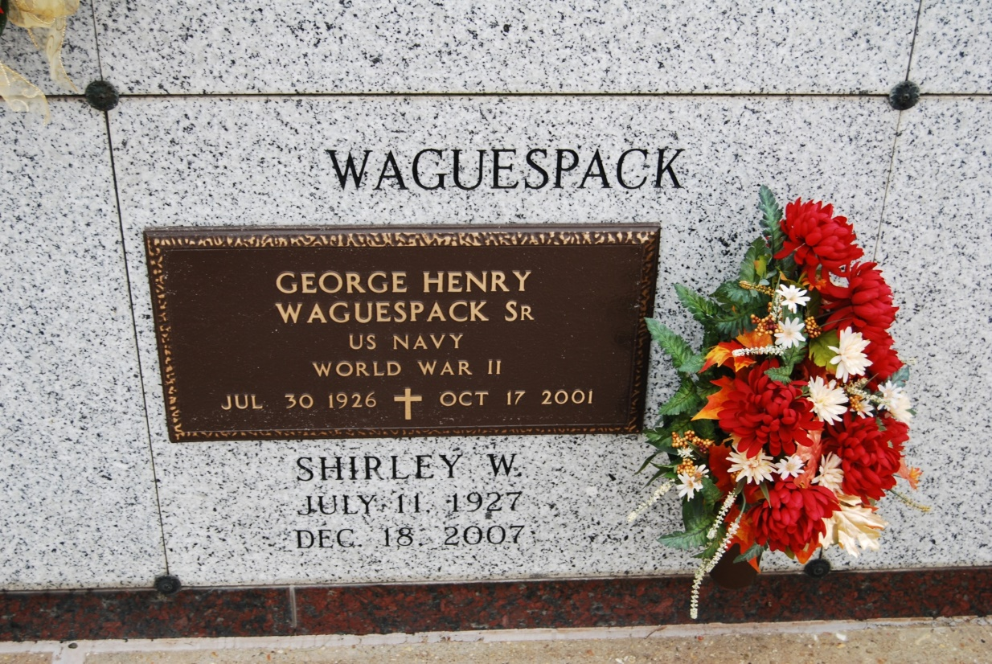

Photo by Kerry Keller

Shirley W. Waguespack died on Tuesday, Dec. 18, 2007, in Lutcher. She was 80, the wife of the late George H. Waguespack Sr., daughter of the late Francis and Cecile Waguespack, mother and mother-in-law of Shirley W. and Lee Granier, George H. Jr. and Mary Waguespack, Carroll J. and June Waguespack, Glenn M. and Lona Waguespack, Barry J. and Valerie Waguespack, Patrick G. and Denise Waguespack, and Randal M. and Melinda Waguespack, and sister of Francis Waguespack Jr., Thomas Waguespack, Charles Waguespack, Wayne Waguespack, Mary Ann Borne, Cecile Hymel, Geraldyn Waguespack, Elaine Legendre, Barbara Wood, the late Allen Waguespack, and Albert Waguespack. She is also survived by 20 grandchildren and five great-grandchildren. She was a native and resident of Vacherie. Visitation at St. Philip Catholic Church, Vacherie, on Friday, Dec. 21, from 8 a.m. until Mass of Christian Burial at 11 a.m., with the Rev. Clarence Waguespack, celebrant. Entombment in the church mausoleum. Arrangements by Alexander Funeral Home of Lutcher.

The Advocate (Baton Rouge, LA)

December 20, 2007