Virgia (Hymel) Waguespack
Abt. 1932 – May 13, 2024

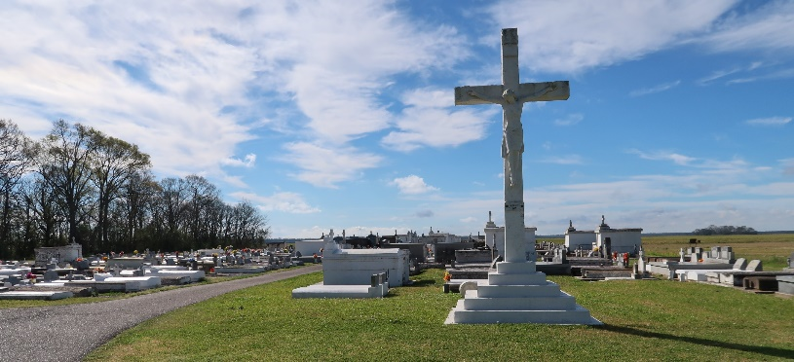

Virgia Hymel Waguespack, a native and resident of Vacherie, Louisiana, passed away on May 13, 2024, less than a month shy of her 92nd birthday. She was the loving wife of the late Adam T. Waguespack, Jr., and the mother of Anthony (Jeanne) Waguespack, Dale (Helen) Waguespack, Brian (Marcia) Waguespack, Susan (Chad) Weidert, Paul (Pam) Waguespack, and Sheila Holland (Mark Daigle). She is survived by 14 grandchildren and 13 great-grandchildren.
She was the daughter of the late Albon and Fidelise Hymel and the sister of Harry Hymel, Ethel Mae Recatto, Judy Waguespack, Lynn Hymel, and the late Burchman, Jerome, Albon Jr., and Kenneth Hymel, Hazel Rome, and Merilyn Kliebert.
Virgia was a dedicated homemaker, and the perfect model of a true mother and grandmother, always putting her family ahead of herself.
She was a devout Catholic, and a life-long parishioner of St. Philip Catholic Church, where many will remember her strong voice as a member of the mass choir for many years. She was also a member of the Catholic Daughters, once serving as Trustee.
Relatives and friends are invited to attend a Mass of Christian Burial at St. Philip Catholic Church, 1175 LA-18, Vacherie, Louisiana, on Friday, May 17, 2024, at 12:00 p.m. Visitation will be held at the church from 9:30 a.m. to 12:00 p.m. Interment will be at the St. Philip Catholic Church Mausoleum in Vacherie.

Rose Lynn Funeral Home, Lutcher, Louisiana
May 18, 2024

