Vivian A. (Faucheux Waguespack

January 20, 1936 - May 23, 2021

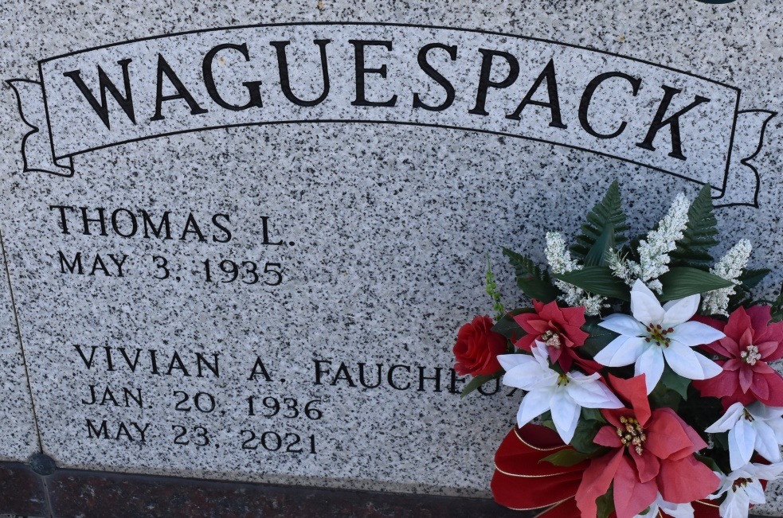

         Vivian Faucheux Waguespack, age 85, passed away at her home surrounded by family on May 23, 2021 after a battle with Alzheimer’s. She was a native of Wallace and a resident of Vacherie for the last 60 years. She was happily married for 60 years to her husband, Thomas L. Waguespack. She enjoyed spending time with her children and grandchildren. She was a member of the Catholic Daughters of Court St. Philip 1504.

         She is survived by her husband Thomas L. Waguespack; children, Daniel Waguespack (Chantal), Kim Benoit (Bryan), Connie Pittman (Gary), Lisa Becnel (Jude), Kelly Clayton (Daniel), & Mary Gros (Carl); her eleven grandchildren, Thomas & Cameron Waguespack, Alanna & Philip Benoit, Heidi P. Grasoff & Samantha Pittman, Emily & Erin Becnel, Morgan & Jacob Clayton, & Brandon Gros; and her siblings, Mabel Cazenave and Clifford Faucheux.

         She is preceded in death by her parents Fergus & Noelie Faucheux. She was the sister of the late Enola, Lewis, Lynn, Malvin, Lucien, & Clarence Faucheux.

         The family would like to thank Renda Roussell, Julie Suski, Ann Rodrigue, Dr. Jason A. Higgins, & the staff at Haydel Memorial Hospice of Houma for their compassionate care.

         A visitation in her honor will be held on Thursday, May 27, 2021 from 9:00 AM to 11:00 AM at St. Philip Catholic Church in Vacherie, Louisiana.  A Mass of Christian Burial will begin at 11:00 AM.  Burial will follow in the church cemetery.

Rose Lynn Funeral Home, Lutcher, Louisiana; June 26, 2022