Wade Gerard Waguespack

August 28, 1952 – November 3, 2007

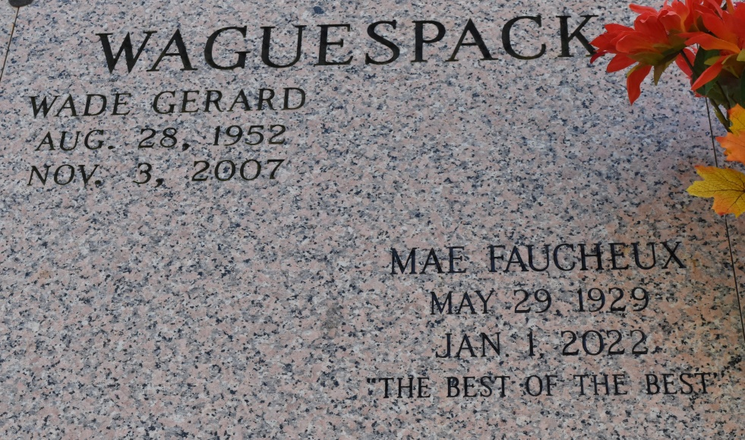

Wade Gerard Waguespack departed this life at 2:50am (CST) on Saturday, November 3, 2007 in Mayapur, India after a battle with cancer. He was 55 years old. He was a native of Gretna, LA and a resident of Atlanta, GA and Sandy Ridge, NC. He is the eldest son of Nolan E. Waguespack, Sr. and Mae Faucheux Waguespack of Vacherie, La.

He leaves behind his parents, ex-wife & friend Vicki Casey, brother Nolan Waguespack, Jr. & wife Teresa, sister Julie W. Poirier & husband David, brother Glenn Waguespack & wife Susan, sister Mary W. Marino & husband Lance, and sister Lisa W. Guillot & husband Lloyd. He also leaves behind 16 nieces and nephews.

He will be missed by all. Relatives and friends of the family are invited to attend the Memorial Mass at St. Phillip Catholic Church, 1175 La. Hwy. 18, Vacherie, LA on Friday November 30, 2007 at 11:00 am.

Published by The Times-Picayune, New Orleans, LA on Nov. 29, 2007.