Michael Edward Walcavich

February 11, 1949 – August 2, 2019

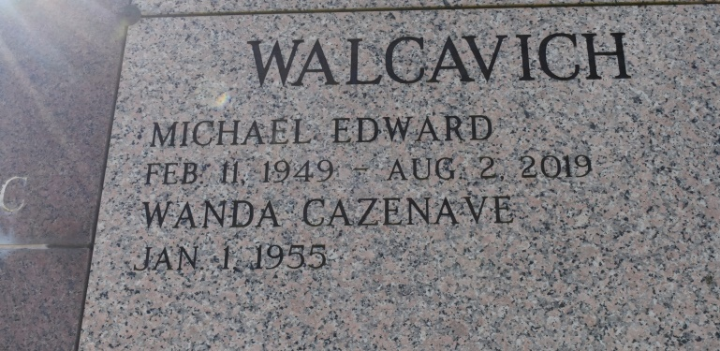

Michael Edward Walcavich, age 70, passed away on August 2, 2019. He was born on February 11, 1949, in Washington, DC. He received his B.S. in Civil Engineering from Virginia Tech. He spent the majority of his professional life working for Texaco and Plains All American Pipeline before retiring from both. In retirement, he enjoyed cycling with the Benders Landing Cycling Group, was a member of the Sts. Simon and Jude Catholic Parish in The Woodlands, and immensely enjoyed spending time with his wife and children.

Mike was preceded in death by his father, Edward Walcavich. A devoted husband and father, he is survived by his wife, Wanda Cazenave Walcavich; daughter, Elizabeth; son, Andrew and his fiancée Jennifer; his mother, Margie Walcavich; and siblings, Deborah W. Noyes and Gregory Walcavich.

Friends are invited to begin visiting with the family at 9 AM on Friday, August 9, 2019 with a Memorial Mass to be celebrated at 11 AM at St. Philip Catholic Church, 1175 LA 18, Vacherie, LA 70090. In lieu of flowers, contributions may be made to Christ the King LSU Catholic Church at CTKLSU-weshareonline.org.

<http://splc-r.com/yahoo_site_admin/assets/docs/Michael_Edward_Walcavich_Obit_8-2019.22264006.pdf>

Accessed August 9, 2022