Sy'Reese Washington
January 23, 2006 - October 10, 2024

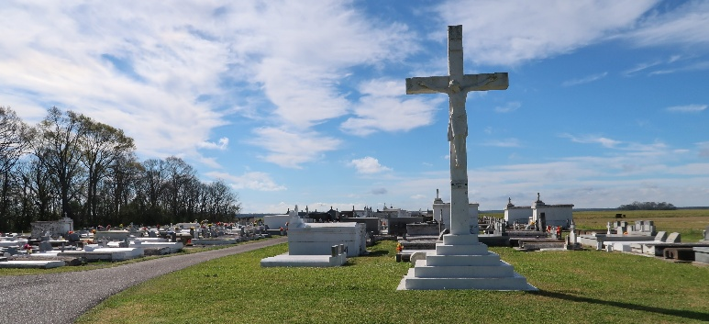

Sy’Reese Ja’Lia Washington was born on January 23, 2006 in Houma, LA to Marie Washington and Nolan Zenon. Sy’Reese walked into the loving arms of Jesus Christ, on October 10, 2024 at the age of 18. Shy, as she was affectionately known by her family and friends, was raised by her grandparents Deidra Zenon and Jessie Bannister. She was educated in the St. James parish school system and had plans to attend cosmetology school. She had a passion for doing hair and could often be found doing her family members’ hair. From a young girl Shy always loved children and babysat many of her family members, including her younger siblings Kaleigh, Kassidy, Liam, and Lailani and her niece Ni’Ari who she spoiled. She even would dog-sit from time to time and took especially good care of her dog, Sassy. In her short life, Sy’Reese was loved and spoiled by many.
She leaves to cherish her memory, her parents Marie Washington and Nolan (Lindsey) Zenon, her grandparents Deidra Zenon, Nolan (Mary) Smith, Jessie Bannister, Arlene Washington, Leonard Braxton and David Charles, and her “Missy” Kaye Henry, siblings Shaneque, Donkiella, Elasher, and Ashley Washington, Nyla Batiste, Nolan, Ayden, Kaleigh, Kassidy, Liam and Lailani Zenon, aunts Nathalie (Shane) and Ny’oshi Smith, and Janette Charles, uncles Larry, Derrick, and David Washington, Calvin, Jason, and Kenny Zenon, and Chad Jasmin, and godparents Nathalie Smith and Ronsheka Hilaire, Owen Malancon Sr, RaShaun Augillard, Kalen Lassere, Cory Jones and Nathaniel Gary, and nieces Madison Washington and Ni’Ari Bright, devoted friend Tirese Flowers; best friends Karrson Charles and Jarrius Robertson; and a host of other family members and friends.
She was preceded in death by her great-grandfather Clarence Zenon, great-grandmother Leona Washington, and uncles Jensen Washington and David and Thomas Smith, Allen Zenon.
A Mass of Christian Burial will be held on Tuesday, October 22, 2024 at St. Philip Catholic Church, 1175 Highway 18, Vacherie, LA 70090 for 11:00AM. Visitation from 9:00AM until service time. Father Mike O’Rourke, Celebrant. Interment St. Philip Catholic Church Cemetery.

Treasures of Life Funeral Services, Gramercy, Louisiana
November 8, 2024

