Melvin Wiltz
June 30, 1943 - April 21, 2024

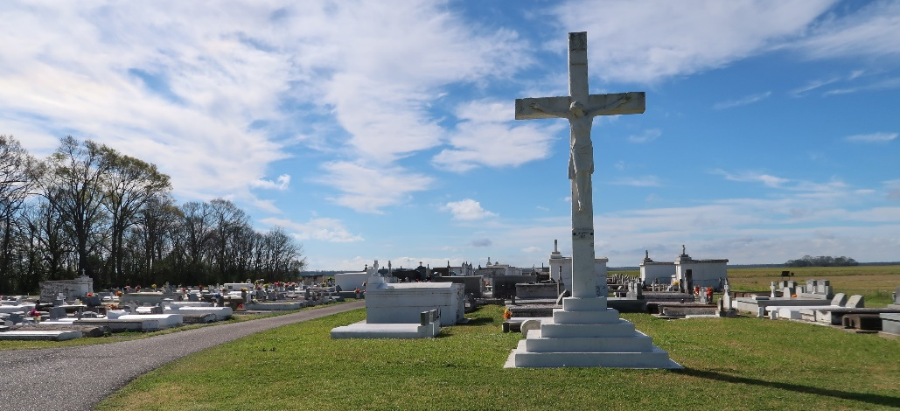

On Sunday, April 21, 2024, Melvin “Shock” Wiltz passed away at the age of 80. Melvin was born in New Orleans, LA, and was a resident of Wallace, LA. He is survived by his daughter, Dranell Wiltz; sister, Eunice Wiltz; Godchild, Vanessa Maiden; and a host of nieces, nephews, other relatives, and friends.
Melvin is preceded in death by his parents, Adlus and Leboria C. Wiltz, Sr.; siblings, Ida W. Jackson, Adlus Wiltz, Jr., Clinton Wiltz, Velma W. Dumas, and Doris W. Frazier; niece, Bridgette W. Domino; and great-nephews, Chance Frazier, Ramon Domino, and Demarkus Wiltz.
Family and friends are invited to attend the Visitation on Friday, April 26, 2024, at Treasures of Life Funeral Services, 315 E Airline Hwy., Gramercy, LA 70052, from 3PM to 5PM. A Mass of Christian burial will be held on Saturday, April 27, 2024, at St. Philip Catholic Church 1175 LA-18, Vacherie, LA 70090. Visitation from 9AM to 10:45AM, followed by a Funeral Mass at 11AM. Father Mike O’Rouke, Celebrant. Interment to follow at St. Philip Catholic Church Cemetery.

Treasures of Life Funeral Services, Gramercy, LA
April 25, 2024

