Oscar A. Zeno Sr.

November 7, 1939 – January 9, 2012

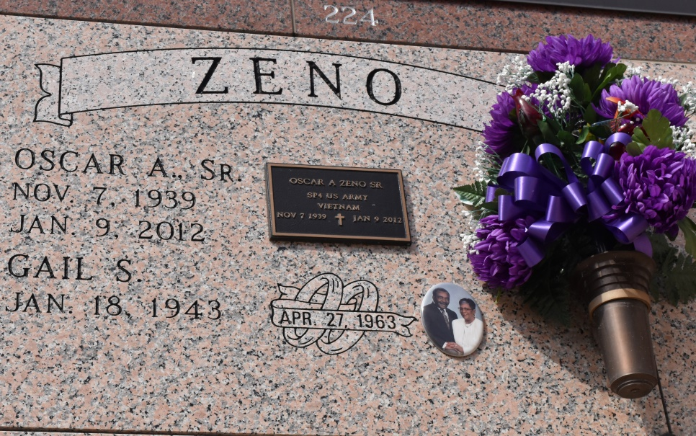

Oscar A. "Zee" Zeno, Sr., of Vacherie, Louisiana, passed away Monday, January 9, 2012 at the age of 72. He was born to the late Clement Zeno and Sophia Bush Zeno Joseph. Stepfather Albert Joseph. Husband of Gayle Schexnayder Zeno. Father of Oscar A. Zeno, Jr. (Katherine), Terry Ann Zeno, Paula and Lorette Joseph. Grandfather of Terrion, Malayia, Sydney, Ty, Melvin, Alisha and Demore and one great-grandchild, Kenton. Brother of Claudia Z. Moore, Floyd and Raymond Bush and Gerald Smith, Letitia Z. Johnson, Regina Z. Lewis, Vanessa and Pecolia Bush of Dallas, Texas. Stepsisters: Nolia Gibson and Loin Roussell. Son-in-law of the late Guy and Louise Favorite Schexnayder. Brother-in-law of Harvey (Betty), Guy Eugene (Jane), Hardy (Veronica), Karl ( Darlene) Schexnayder, Winnie S. Clark, Ruby S. Zenon, Earline S. Jackson and Linda (Larry) Carey. The godfather of Troy Zenon, Burnell Gordon, O.J. Jasmin, Nicole Sterling, Denair Clark and Anissa Bush. Also survived by a host of nephews, nieces, cousins, and friends.

Relatives and friends are invited to attend the Funeral Services on Friday, January 13, 2012 at 11:00 a.m. St. Phillip Catholic Church, 1175 Hwy. 18, Vacherie, Louisiana. Visitation from 8:30 a.m. until time of service. Services will be officiated by Father Louis Oubre. Interment Church Cemetery. Funeral entrusted by The Baloney Funeral Home, LLC 399 Earl Baloney Street, Garyville, Louisiana 985-535-2540. Condolences can be expressed at: [www.baloneyfuneralhome.com](http://www.baloneyfuneralhome.com/)

Published by The Times-Picayune, New Orleans, LA from Jan. 11 to Jan. 12, 2012.