Allen Anthony Zenon

March 20, 1985 – November 24, 2018

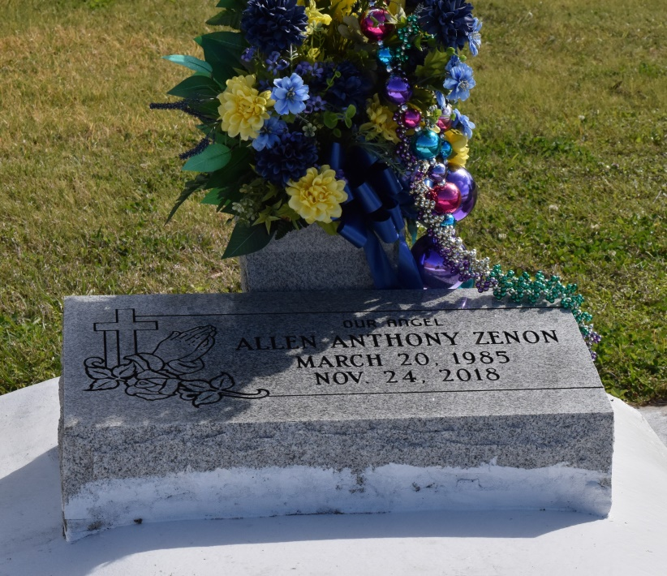

God is our refuge and strength, a very present help in trouble. Psalms 46:1  
 It is upon the strength of his faith and convictions Allen Anthony “Bruza” Zenon, a loving husband, father, son, nephew, cousin departed his earthly life on November 24, 2018 at his home in Vacherie, La. One’s life should not be measured by the years lived but rather by the love for God, family, friends and community. Allen fulfilled this persona. Allen was born on March 20, 1985, the second child of Rene Zenon and Joseph Steib. He was baptized on May 26, 1985 by the late Rev. Salvador Moran at St. Philip Catholic Church, Vacherie, Louisiana.  
 Allen had a personal relationship with God. Had it not been for the love GOD had for Allen, 14 years ago, this young man’s life would have ended in 2004. But GOD heard the prayers and poured out His blessings. Allen never forgot God’s favor and always strived to become a better person for the betterment of families, friends and community. Bruza attended St. James Parish Public Schools. During his lifespan, he worked on several construction jobs in various positions. At the time of his departure, Allen was employed by Brock Industries as a carpenter.  
 Family was very important to him. On March 11, 2017, Allen married his longtime best friend Ayanna C. Burton and pledged his unwavering love to her in front of a gathering of families and friends. With this union his sons, Ashton, Allyn and Abram were provided a stronger family foundation for their growth and prosperity.  
 A die-hard Atlanta Falcons fan always holding true to his red, white and black Falcons colors. Bruza can be heard trash talking other NFL teams because to him there was only one “real” NFL team, although the Falcons never won a Super Bowl. An avid sports fan he can be found on Friday nights cheering on those St. James High Wildcats or on Saturday morning assistant coaching of the Vacherie Rams. From Falcons to Wildcats to Vacherie Rams, Bruza loved his football.  
 It has been said that Bruza was the life of family gatherings. He loved to dance because HE thought he was a good dancer; although Ayanna said otherwise. Allen was a truly a free spirit who loved sharing words of wisdoms…solicited or not. He exhibited his love for family in all that he did from showing up early to set up to utilizing his extraordinary cooking skills. Bruza was known for his cooking skills; although his wife taught him how to cook his first pot of gumbo. Yet, his exceptional boiling skills was sought by all.  
 He will truly be missed by his family and friends. Allen leaves to cherish his memories his loving and devoted wife Ayanna, their sons, Ashton, Allyn, and Abram, his parents Rene Zenon of Vacherie, La. and Joseph(Natalie)Steib of Thibodaux, La.; grandmother Ruby Schexnayder Zenon, Vacherie, La.; godparents, Grant Steib, Luling, La. and Colleen Hurst; New Orleans, La.; brothers, Calvin (Dominique)Zenon, Baton Rouge, La., Jason Zenon, Kenny(Jessica)Zenon, Vacherie, La. and Jai Steib, Iowa, sister, Desiree Champagne, Hahnville, La., mother-in-law Desirre Octave, Vacherie, La., father-in-law Levon (Sandra) Burton, Knoxville, Tennessee.; sisters-in-law, Anissa (Ridge) Bush, Baton Rouge, La., Kiara Johnson, Vacherie, La., Ebony Burton, Seattle, Washington and Raevon Burton, Knoxville, Tennessee; brothers-in-law, Levon Burton II and Devon Burton, Knoxville, Tennessee; godchildren, Jordai Valentine, Ryjanae Edwards, Vacherie, La. and Kristi Jones, Houston, Texas; aunts, Denise Quezaire of Paulina, Roxane Zenon, Deidra Zenon, Nina (Avery) Joseph, Joann (Anthony) Jasmin, Jennifer Steib and Alethia Steib all of Vacherie, La. Colleen (Leroy) Hurst of New Orleans; his uncles Troy Zenon, Fabian Zenon and Kim (Melanie) Vedol of Vacherie, La. and Brian (Anez) Steib of Marrero; a host of aunts and uncles-in-law who treated him like their own. He also leaves extended families, Thaddeus (Laura) Sutherland and Gwen Williams families; lifelong friends Thaddeus Sutherland Jr, Damian Blain, Darron Cage Jr. and Jordy Valentine. A host of nieces, nephews, and cousins, other relatives and friends; whom he loved dearly.  
 He was preceded in death by his grandparents Clarence Zenon, Gasilia and Joseph Steib, Sr., cousin, Troy Zenon Jr. and his uncle Glynn Quezaire.  
A Mass of Christian Burial will be held on Saturday, December 1, 2018 from St. Philip Catholic Church, 1175 Highway 18, Vacherie, LA 70090 for 11:00AM. Visitation from 9:00 AM until service time. Father Matthew McCaughey, Celebrant. There will be a gathering of family and friends on Friday, November 30, 2018 from Treasures of Life Funeral Services from 2:00PM – 4:00PM. Interment St. Philip Catholic Church Cemetery. Treasures of Life Funeral Services entrusted with his final care. 315 E. Airline Hwy, Gramercy, LA 70052.

Treasure of Life Funeral Services, Gramercy, Louisiana