Samentha (Brown) Zenon

September 30, 1930 – February 12, 2006

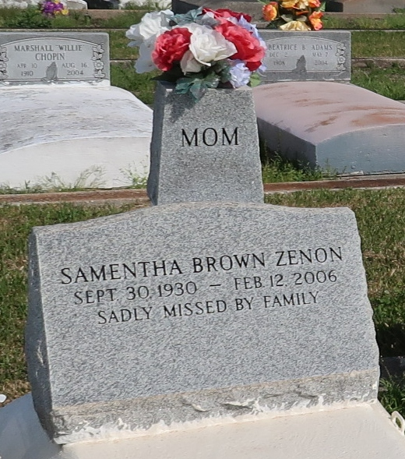

Samentha Brown Zenon passed away on Sunday, February 12, 2006 at St. James Hospital at the age of 75 years old. Daughter of the late Elverin Davis and Robert Brown, Sr. Beloved wife of Earl Zenon, Jr. Mother of Larry, Bruce, David, Ronnie and Victor Zenon, Brenda Z. Frankin, Linda Z. Hilaire, Cynthia Z. Benoit, the late Betty Z. Franklin and Kenneth Zenon. Sister of Robert Brown, Jr. Also survived by a host of nieces, nephews, grandchildren and great grandchildren.

Relatives and friends of the family are invited to attend a Funeral Service on Wednesday, January, February 15, 2006 at 11:00am at St. Phillip Catholic Church, Vacherie, LA. Visitation will be held from 9:00 until 11:00am. Interment: St. Phillip Catholic Church Cemetery in Vacherie, LA. Arrangements by Rhodes United Fidelity Funeral Home, 2929 Scenic Hwy., Baton Rouge, LA.

Published by The Times-Picayune, New Orleans, Louisiana on Feb. 14, 2006.