Eugene J. Zeringue Jr.

1931 – November 21, 2014

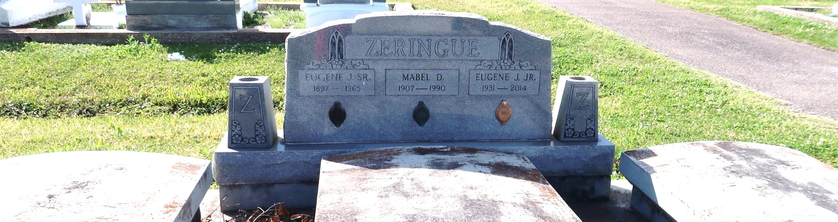

Eugene "Gene" Zeringue Jr. passed away Friday, November 21, 2014. He was born in Wallace, Louisiana, to the late Eugene and Mabel Zeringue. He is also preceded in death by his brother, Raymond Zeringue and sister, Ruth Brignac. Gene is survived by his two sisters, Verna Longmire (Norman) and Murial Cacibauda, his Godchild Michael Longmire (Jacqueline) and numerous nieces and nephews. He is also survived by his longtime companion, Diana Akes, the love of his life. Condolences may be expressed at [www.HCAlexanderFuneralHome.com.](http://www.hcalexanderfuneralhome.com/)

Published by The New Orleans Advocate from Nov. 25 to Nov. 28, 2014.