Lucette (Haydel) Hidalgo

April 23, 1922 - August 19, 2019

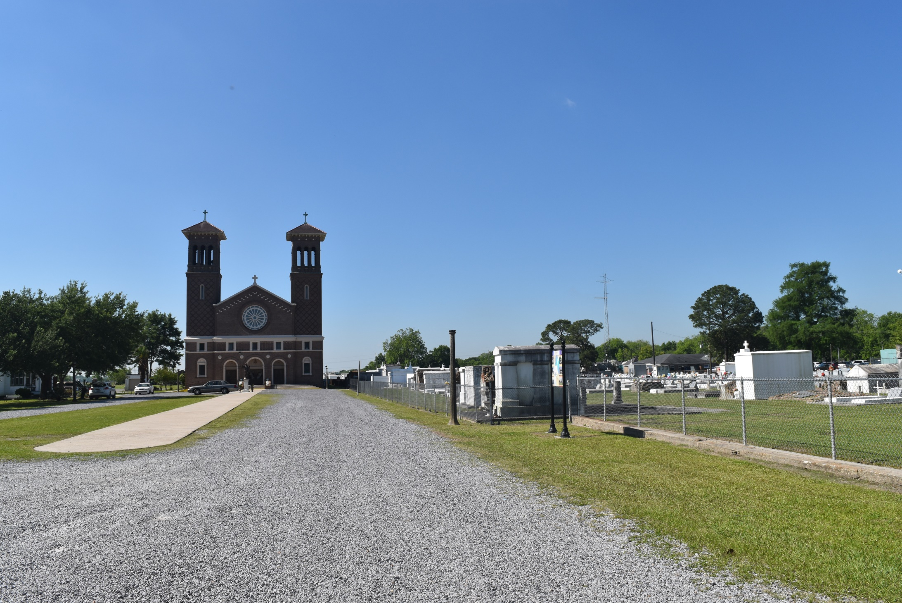

Lucette Haydel Hidalgo passed away on Monday, August 19, 2019 at the age of 97. She was a native of LaPlace, LA and a resident of Reserve, LA.   
 Beloved wife of the late State Hidalgo, Jr. Daughter of the late Lucette Madere Haydel and Edgar Haydel, Sr. Sister of the late Aline H. Holmes, Alma H. St. Pierre, Rita H. Gautreaux, Doris H. Vicknair and Edgar Haydel, Jr. Also survived by many nieces and nephews.  
 Relatives and friends are invited to attend the Funeral Mass at St. Peter Catholic Church, 1550 Hwy 44, Reserve on Thursday, August 22, 2019, at 11:00 a.m. Visitation will begin in church at 9:00 a.m. Interment in St. Peter Cemetery. Arrangements by Millet-Guidry Funeral Home.

Millet-Guidry Funeral Home, LaPlace, LA

(accessed 8/21/2019)