Gardenia Hilaire

September 18, 1956 – July 31, 2020

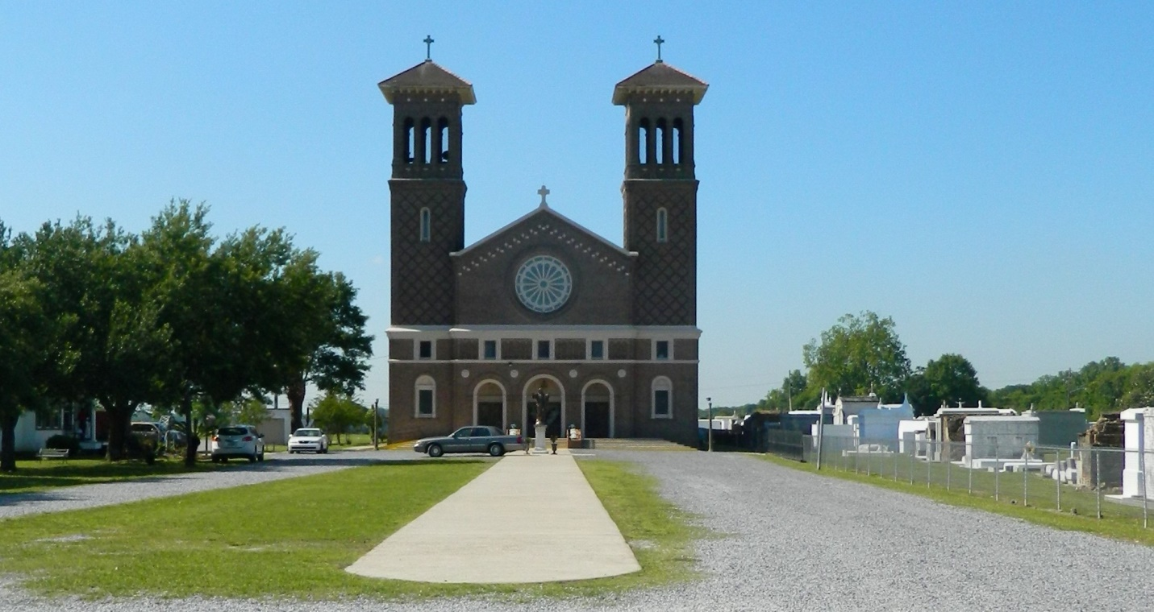

Gardenia ""Gussy"" Hilaire entered eternal rest on Friday, July 31, 2020 at Chateau St. James Nursing Home at the age 63. She was born to Joseph Hilaire, Sr. and the late Helen Lumar Hilaire on September 18, 1956 in New Orleans, LA. She graduated from Edgard High School in Edgard, LA. Gardenia was a loving and caring daughter, mother, sister, aunt and friend. She was well known for her love and hospitality, which had no boundaries. She showered all of her nieces and nephews with love and made her house their second home. Gussy never met a stranger and she was always the life of the party. Her infectious smile and outgoing personality brightened any room she graced with her presence. To know her was to love her. She took pride in caring for others because it was her vocation and dedication to the Commandments of God. Her love and hospitality transcended into her profession as a housekeeper at the Hilton New Orleans Airport Hotel in Kenner, LA, where she worked for many years. She was well-known and greatly loved by all of her colleagues. Mourning her departure while still loving all the great memories are her son Chad, daughter-in-law Dawana, grandchildren Alayla and Alana, nephew whom she loved and cared for as a second son Steven Brignac, III, father Joseph Hilaire, Sr., brothers Lee (Sheila), Tracy (Lynette), Randy (Carol), Reginald (Vashita), sisters Demetris (Curtis), Rolander (Dwayne), sister-in-law Gayle, Godchildren Kentrell Lumar and Jade Mitchell, along with a host of nieces, nephews, other relatives and friends. She was preceded in death by her mother Helen Lumar Hilaire, brother Joseph Hilaire, Jr., and both paternal and maternal grandparents. A public walk-through viewing will be held on Thursday, August 6, 2020 at Treasures of Life Funeral Center, 315 E. Airline Hwy, Gramercy, LA, from 5:00 pm to 7:00 pm. A Mass of Christian Burial will be held on Friday, August 7, 2020 at St. John the Baptist Catholic Church 2349 LA-18, Edgard, LA 70049 at 10 am. Interment to follow at St. John the Baptist Catholic Church Cemetery, Edgard, LA. Final care entrusted to Treasures of Life Funeral Services, 315 E. Airline Highway, Gramercy, LA 70052. Masks are required!

Published in The Times-Picayune from Aug. 4 to Aug. 7, 2020.