Helen (Lumar) Hilaire

Abt. 1935 – March 24, 2020

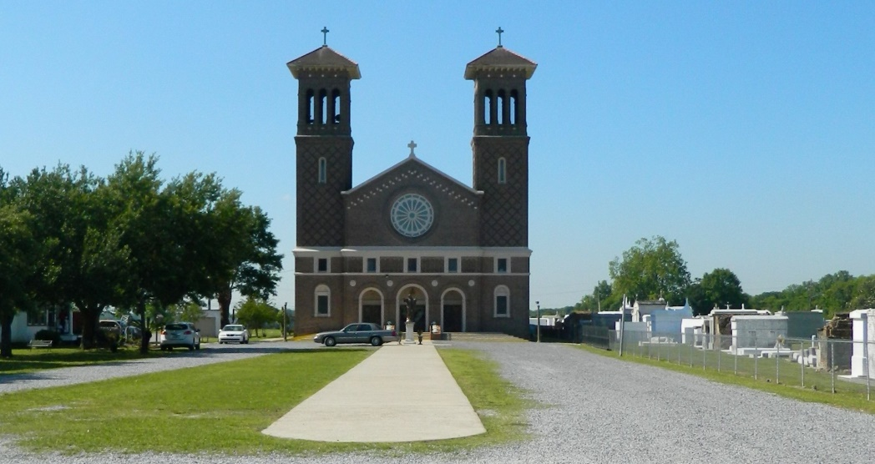

Helen Lumar Hilaire entered into eternal rest on Tuesday, March 24, 2020 at the age of 85. Beloved and loving daughter of the late Ameila and Whitney Lumar. She leaves to cherish memories, her beloved husband, Joseph “Fox” Hilaire of 68 years. Helen was an amazing wife, mother, grandmother, relative, and friend. She brought energy and laughter whenever she entered a room, and she never met a stranger.  
 Helen had a calling to serve children through her commitment to the education system for over 30 years, dedicating herself to the children of St. John the Baptist Parish Schools. She was a devoted member of St. John the Baptist Parish Catholic Church, which included blessing many ears and hearts with her beautiful voice as a member of the church choir. Helen was also a dedicated member of the Ladies Auxiliary Court #66 and the Altar Society. Her passions were her family; cooking the World’s Greatest Tea Cookies, Baked Spaghetti, and many more delectable meals; and bringing laughter and joy to all. Helen was devoted to the Council on Aging Program and improving outcomes for all citizens of Edgard.  
 Mourning her departure while cherishing precious memories are her eight children, Joseph Hilaire (Gail), Lee Hilaire (Sheila), Gardenia Hilaire, Tracy Hilaire, Sr. (Lynette), Randy Hilaire, Sr. (Carol), Reginald Hilaire (Vashita), Demetris Young (Curtis), Rolander Bradley (Dwayne); sister, Edna Lumar; sisters-in-law, Philomena Lumar, Evelyn Barre, Juanita Green; 22 grandchildren; 27 great-grandchildren; a special friend and BINGO buddy, Roslynn Roussel; and a host of other relatives and friends.  
 She was preceded in death by her mother, Ameila Lumar; father, Whitney Lumar; sisters, Ceola Lumar, Evelyn Lumar, Betrice Edwards (Ernest), Camille Lumar; and brothers, Sterling Lumar, and Lawrence Lumar. Final care entrusted to Treasures of Life Funeral Services, 315 E. Airline Highway, Gramercy, LA 70052.

Treasures of Life Funeral Home, Gramercy, LA

March 31, 2020