Rev. Joseph Hilaire Jr.

Abt. 1933 – July 15, 2020

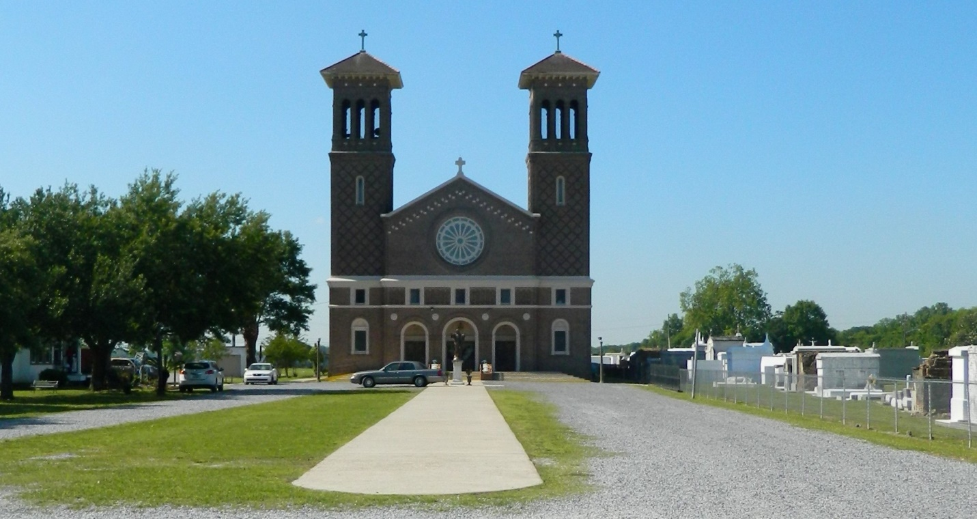

Rev. Joseph "Ponchie" Hilaire Jr. entered eternal rest on Wednesday July 15 at the age of 67. He was the beloved son of Joseph Hilaire Sr. and the late Helen Lumar Hilaire. He was a devoted husband of 46 years to Gayle Milton Hilaire and to this union was born one son, Traviss Hilaire. Ponchie was a warm and gentle man known for his love for Christ. As a young boy he attended St. John the Baptist Catholic Church where he served as an altar boy. He was baptized on May 15, 1994 by Rev. Vernon Alexander at Greater New St. Peter Baptist Church. Continuing his Christian walk and furthering his Christian education, he went on to attend Union Baptist Theological Seminary. On August 18, 2000, he began to fulfill God's calling when he was ordained as a Minister by Pastor Willie Smith with the Central Union Baptist Association. Once a Minister, he perfected his call of duties by keeping God first in everything he did. He ministered everywhere he went and to everyone he knew. His purpose to God was to save lives and win souls, a job well done by him. In 2017, he retired after many years with Pinnacle Polymers. Once retired, he began to spend even more time with family. His wife, son, daughter-in-law, and his grandchildren brought much joy to his life. His relationship with his family was abundant. He was loved and well respected by his family and the community he served. He was always praying and encouraging his family to live according to God's Holy Word. He took pride in caring for his parents and being an older brother to his siblings. His tone was soft and gentle, but his words were powerful. Mourning his departure, while cherishing his precious memories are his wife, Gayle Hilaire; his son, Traviss; daughter-in-law, Jannessa; grandchildren, Janelle, Tyler, Jaida, Trinity; father, Joseph Sr; brothers, Lee (Shelia), Tracy (Lynette), Randy (Carol), Reggie (Vashita); sisters, Gardenia, Demetris (Curtis) Young, Rolander (Dwayne) Bradley; mother-in-law, Florence Milton; sister-in-law, Zilda Dukes, Brenda Milton, Harriet Gros; special friend, Ormond Keller (Pee wee); Godchildren, Rojanne Tilton, Genelda Cannon, Kim Baily and Demoine Gros; and a host of nieces, nephews, relatives, and friends. He was preceded in death by his mother, Helen Hilaire; father-in-law, Freddie Milton Sr.; brother-in-law, Freddie Milton Jr.; and both paternal and maternal grandparents. A viewing was held on Monday, July 20, 2020, from 4PM – 7PM at Greater New St. Peter Baptist Church, 200 West 3rd St., Edgard, LA. A private funeral will be held on Tuesday, July 21, 2020, at 11AM at Greater New St. Peter Baptist Church, with a burial immediately following at St. John the Baptist Catholic Church Cemetery. Final care entrusted to Treasures of Life Funeral Services, 315 E. Airline Highway, Gramercy, LA 70052. To share condolences and thoughts, and to sign guest book, please visit: [www.treasurefunerals.com.](http://www.treasurefunerals.com/) Due to Covid-19 Virus please wear a mask and practice social distancing.

Published in The Times-Picayune (New Orleans, LA) from Jul. 20 to Jul. 23, 2020.