Inez (Webre) Hymel

March 12, 1921 – March 24, 2012

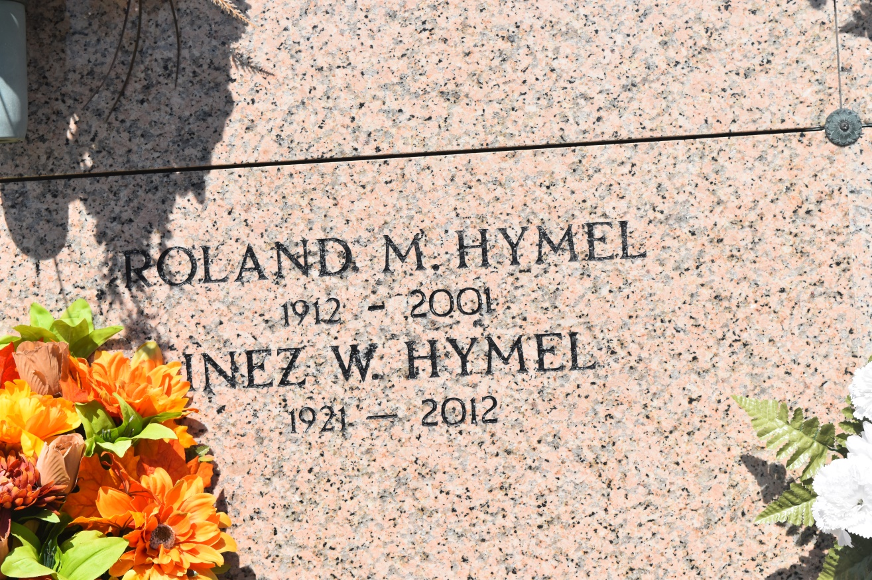

Inez Webre Hymel, age 91, passed away Saturday, March 24, 2012, at Thibodaux Regional Medical Center. She was a resident of Vacherie, LA and a native of Edgard, LA. Inez was preceded in death by her parents, Estelle Rapp Webre and Olide Webre; four brothers, Ovide, Nestor, Charles and Lynn Webre; three sisters, Fernande Laurent, Regina Brou, and Therese Schexnayder. She was the wife of the late Roland Hymel Sr. Inez is survived by one daughter, Jerelyn Hymel Infante, of Vacherie; three sons, Roland Jr. and Gloria Talbot Hymel, of Praireville, Carroll and Mary Lee Tregre Hymel, of Vacherie, and Leslie and Julie Becnel Hymel, of Vacherie; also eight grandchildren, nine great-grandchildren, numerous nieces, nephews, other relatives and friends. Relatives and friends of the family are invited to attend the visitation Tuesday, March 27, beginning at 12 p.m., followed with a Funeral Mass at 2 p.m. at St. Phillip Catholic Church in Vacherie. Interment will be in St. John the Baptist Cemetery, Edgard, LA. She was a member of the Ladies Altar Society and the League of the Sacred Heart St. Phillip Catholic Church.

Advocate, The (Baton Rouge, LA) - Monday, March 26, 2012

Contributed by Jane Edson