Roland M. Hymel Sr.

1912 – October 16, 2001

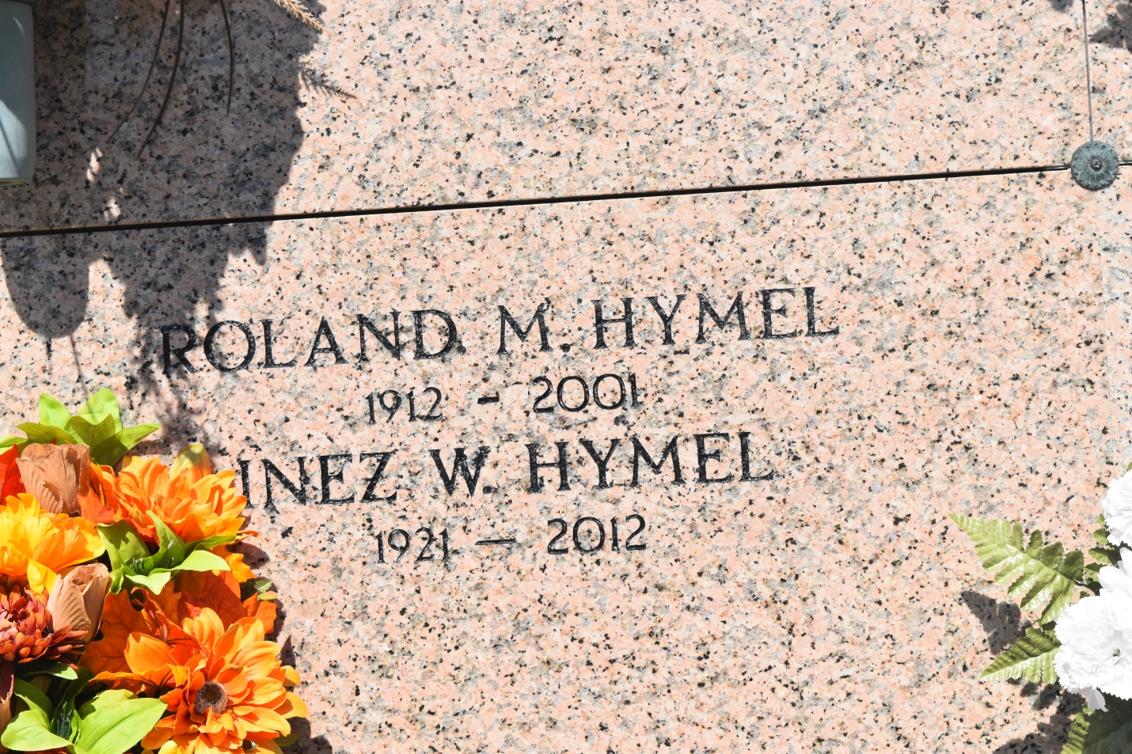

Bottom of Form

SOUTH VACHERIE - Roland Martin "Johnny" Hymel Sr., 89, a native and resident of Vacherie, died Oct. 16. He was the husband of Inez Webre Hymel and father of Jerelyn Infante and Roland Jr., Carroll and Leslie Hymel. He was also the son of the late Valsin and Aurelie Abadie Hymel and brother of the late Elvina Hotard and Celima, Dervina, Elise, Hilda, Eula, George, Jules and Francis Hymel Sr. He is also survived by eight grandchildren and four great-grandchildren. He was a former manager of Vacherie Wholesale. Services were Oct. 19 at St. Philip Catholic Church, South Vacherie, with interment at St. John the Baptist Cemetery, Edgard.

L'Observateur, LaPlace, LA; October 20, 2001