Felix James

March 11, 1920 – September 18, 2013

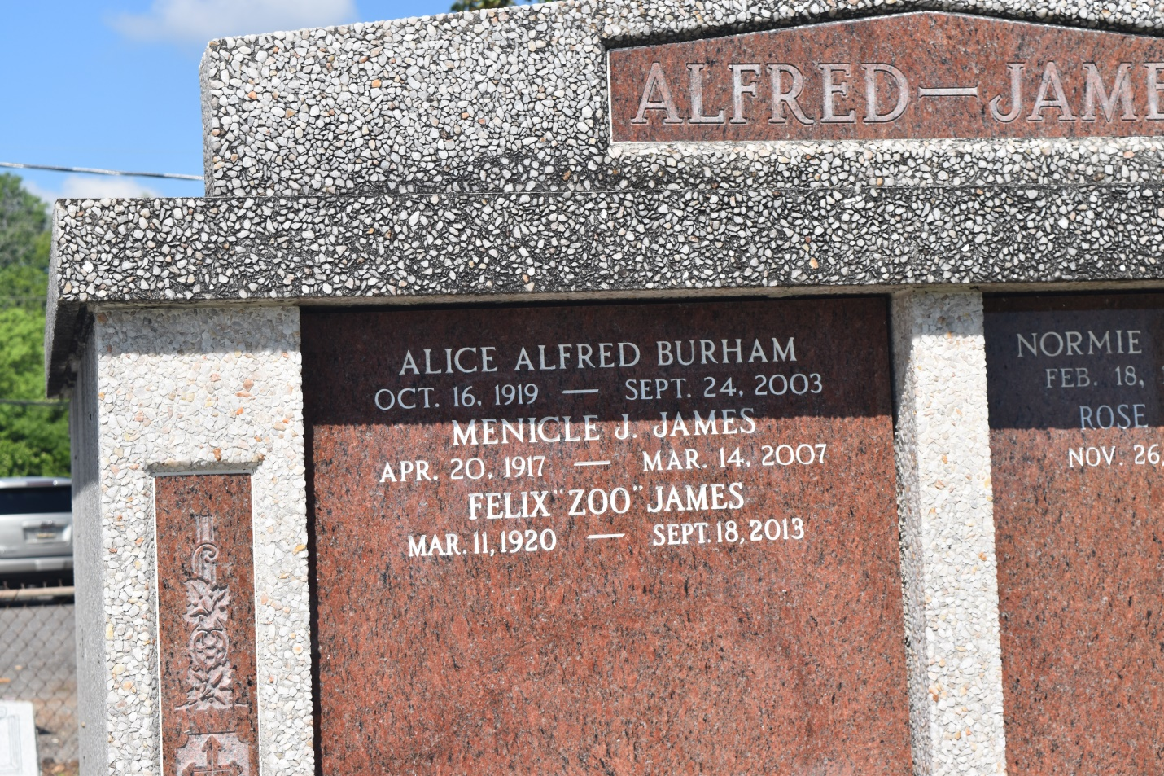

Felix 'Zoo' James, a coach and administrator in New Orleans schools, died Sept. 18 in Memphis, Tenn., of complications from Alzheimer's disease. He was 93.  
 Mr. James was born in Gerard, Ga., and moved with his family to New Orleans when he was 5. He lived in the city until he moved to Memphis after Hurricane Katrina.  
 A graduate of McDonogh No. 35 High School, Mr. James enlisted in the Army Air Corps shortly after earning an undergraduate degree at Xavier University in 1941. At first, he was a member of the Aviation Cadet Training Corps at Tuskegee Army Air Field in Alabama, but he received Medical Corps training at Selfridge Air Force Base in Michigan. He returned to Tuskegee and the 332nd Fighter Group, with whom he served as a medic in Italy during World War II.  
 After the war, Mr. James earned a master's degree in education at Hampton Institute and returned to New Orleans to work at Gaudet School. By the time the school closed, he had been acting principal and coach.  
 He transferred to L.B. Landry High School, as a teacher, and a track, basketball and football coach. During his 15 years as head football coach, the Buccaneers won five district, three city, and two state championships, and several players went on to the National Football League.  
 In 1966, Mr. James was appointed to coordinate federal programs by the city's public schools system. After recruiting white and black college graduates as teachers and special-education evaluators, he was named the system's first African-American personnel director. When he retired, Xavier hired him as athletic director. He stayed there until he was too ill to continue.  
 In 1989, he was inducted into the Greater New Orleans/Sugar Bowl Sports Hall of Fame in 1989. He was a member of the Tuskegee Airmen Association and the Studs and Your Friends clubs.  
 Survivors include his wife, Bonita "Bun" James; a son, Kenneth James of Memphis; a granddaughter; and three great-grandchildren.  
 A funeral will be held Friday at 10 a.m. at St. Luke's Episcopal Church, 1222 N. Dorgenois St. Visitation will start at 8 a.m. Burial will be in St. John the Baptist Catholic Church Cemetery, River Road, Edgard. Majestic Mortuary Services is in charge of arrangements.  
  
Times-Picayune, The: Web Edition Articles (New Orleans, LA) - Friday, September 27, 2013

L. B. Landry Alumni holds memorial for coach Felix James

During the early 1950s through mid-'60s, students from Marrero, Gretna and Harvey crossed Jefferson Parish borders to attend Algiers' L. B. Landry Junior/Senior High School to join the Buccaneers to play football, basketball and run track under coach Felix "Zoo" James.  
 Therefore, it was only natural after James' death on Sept. 18 at age 93 that they return to the new state-of-the-art school, now called Landry-Walker High School, to express condolences and reflect upon the impact he made.  
 Approximately 1,000 former students, players and associates attended the memorial. Former National Football League players Virgil Robinson and Richard Jackson were among other sportsmen and women who came to express respect for the dedicated work and friendship of their high school coach. Among the many other participants on the program were Joseph Ruffin, Jimmy Henderson, Harry Alberts, Charles Rice and Russell Augustine.  
 James' impact upon students' lives was extensive. He worked with Principal Israel M. Augustine Sr. and colleagues to help as many students as possible attain a college education. Under his leadership, he produced 24 college athletes, of which five went on to professional sports. Four were professional football players and one professional baseball player.  
 He and other coaches were instrumental in the acquisition of sports and academic scholarships for many of Landry students who went on to college. He also taught driver's education classes to both male and female students. Many of those in attendance remembered James as the person who first taught them to drive. The reflections brought back many fond memories and stories to those he taught.  
 As adults, many of his former students went on to become employees of New Orleans Public Schools after 1966. They again connected or reconnected with James in his new position as director of personnel for NOPS. One such person is former principal of William J. Fischer Elementary School and Landry alumna, Carol Edgar Lang, who served as mistress of ceremonies for the evening.  
 The Rev. Johnny McKinnis, former football player and track team member, gave the invocation. The Rev. Andrew Douglas, a colleague and former Landry coach, presented reflections. Other reflections came from former player, orthodontist Clarence Red; former track team member, Jefferson Parish School Administrator Clara Thibodeaux Byes; and many others. They all shared reflections of the dedicated, kind, and forceful personality of James.  
 Alumni and committee members responsible for organizing the program are: Richard Jackson, class of 1960; Russell Augustine, class of 1959; Charles Rice, class of 1958; The Friends of Landry, namely Auyna Bryan; Sylvia Anderson; the staff of Landry/Walker High School; the IT and music departments, and the James family, who agreed to have the body brought to the school for the memorial service. Wife Bonita James said that he was a man who loved Algiers, and Algiers loved him. Charles Rice Sr. said, "All worked together to make the program a success."

Times-Picayune, The: Web Edition Articles (New Orleans, LA) - Thursday, October 3, 2013

Contributed by Jane Edson