Menicle Jessie James

April 20 1917 – March 14, 2007

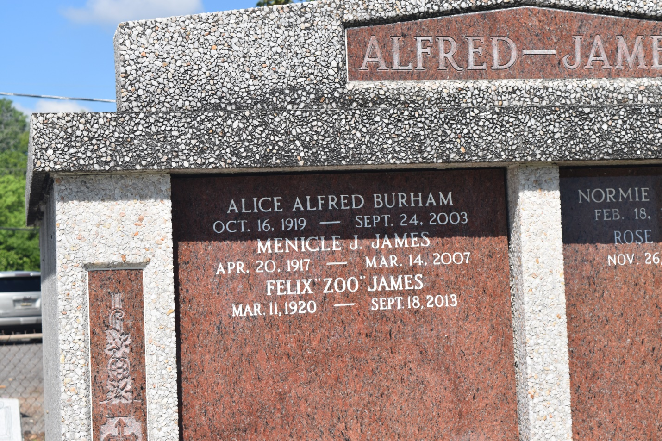

Menicle Jessie "Boy" James on Wednesday, March 14, 2007 in Memphis, TN was called home to be with the Lord. Native of New Orleans, LA., longtime resident of Englewood, NJ and recently of Memphis, TN (evacuated due to Hurricane Katrina). Mr. James was a retired union representative for the Fur & Leather Workers Union.

He was preceded in death by his parents, Norman & Violet Lowe James and several siblings. He leaves to mourn his passing his beloved wife, Rose Gordon James; brother, Felix "Zoo" James; sister-in-law, Bonita Justine James, all of Memphis, TN; nephew, Charles "Hump" James of Los Angeles, CA; niece, Fredia Lacey of New Orleans, LA; along with a host of great and great-great nieces & nephews.  
 Friends and family along with staff & employees of Pratt Stanton Manor & the Orleans Parish School Board are invited to attend the funeral service at Majestic Mortuary, 1833 Oretha C. Haley Blvd., Saturday, March 24, 2007 at 10:00 am. Visitation 9:00-10:00 am. Interment in St. John the Baptist Catholic Church Cemetery in Edgard, LA.

Majestic Mortuary in charge of arrangements.

Times-Picayune, The (New Orleans, LA) - Friday, March 23, 2007

Contributed by Jane Edson