Rose (Gordon) James

November 26, 1910 – January 17, 2008

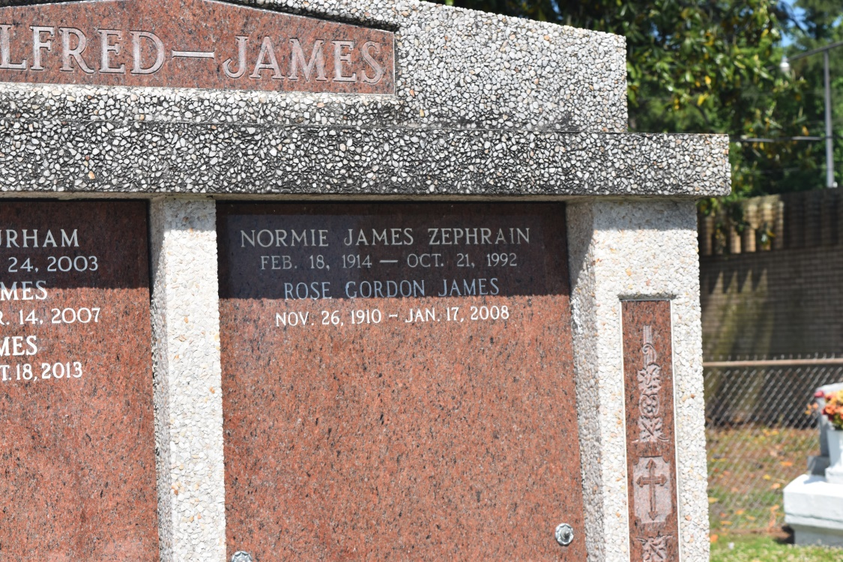

Rose Gordon "Nana, Mama Rose" James, age 97, was called to be with the Lord on Thursday, January 17, 2008 in Nesbit, Mississippi. Mrs. James was a native of New Orleans, LA and long time resident of Englewood, NJ. She was preceded in death by her husband, Menicle Jessie "Boy" James; and parents, Joseph and Florence Gordon. She leaves to mourn her brother-in-law, Felix "Zoo" James and sister-in-law, Bonita Justine James of Memphis, Tennessee; along with a host of nieces and nephews.  
  
Friends and family; along with staff and employees of Pratt Stanton Manor, New Orleans, LA; and Waverly Gardens Retirement Community, Memphis, TN are invited to attend the Funeral Service at Majestic Mortuary, 1833 Oretha C. Haley Blvd., New Orleans, LA, Saturday, January 26, 2008 at 10:00 am. Visitation 9:00-10:00 am. Interment in St. John the Baptist Catholic Cemetery, Edgard, LA.  
  
The family of Rose James wishes to thank Crossroads Hospice Ministry of Memphis, TN and Hospice Ministries of Southhaven, MS for their wonderful support.  
  
Majestic Mortuary In charge of arrangements (504) 523-5872

Times-Picayune, The (New Orleans, LA) - Friday, January 25, 2008

Contributed by Jane Edson