Nova J. Jarrow

April 30, 1939 - January 6, 2023

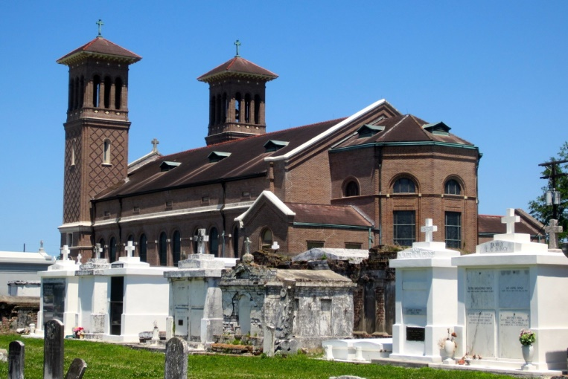

Nova J. Jarrow entered into eternal rest on Friday, January 6, 2023 at Ochsner Medical Center in Kenner, LA.  Nova was born April 30, 1939 in Edgard, Louisiana to Gregoire and Georgiana L. Jarrow.

Nova acknowledged his faith and belief in Jesus Christ at an early age. He was a member of St. John Baptist Catholic Church where he was very active in keeping the candles replaced in the church’s vestibule.

Nova was educated in the St. John Parish Public School system and furthered his education at Delgado Community College in New Orleans, LA where he received a degree in Culinary Arts.

Nova was united in holy matrimony to Gwendolyn Bovie-Jarrow in 1960. From this union, three children were born, Andre, Sr. (Anita) Jarrow, Kenneth (Reonda) Jarrow, and Javon (Gerald) Hart.

Nova was employed at D&L Terrazzo Company in New Orleans, LA. Later, he was employed at Caire & Graugnard in Edgard, LA as a night watchman. Nova affectionally known as “Blue” by his family and friends; enjoyed his life to the fullest and there was no subject he could not talk about. He enjoyed watching “The Price is Right,” soap operas, and his favorite tv shows were Cowboy movies. He found great joy in his grandkids and great grandkids. They brought much laughter to his heart.

Nova’s precious memories are forever embedded in the hearts of his children, Andre Sr. (Anita) and Kenneth (Reonda) Jarrow, his grandchildren, Andre, Jr., Roshni, Broderick, Brandon, Brandelle, Trey, Treyann, and Rashad, 10 great grandchildren, his devoted friend, Sharon Cunningham, son-in-law, Gerald Hart, brother-in-law, Clarence (Mary) Bovie, sister-in-law, Joyce (Charles) Williams, and close friends, Robert Boudoin, Larry Gills, Sr., Sheryl Isom, Christine Robiskie, Veradine Oubre, and Raymond Bailey.

Nova was preceded in death by his parents, wife, Gwendolyn Bovie-Jarrow, daughter, Javon Hart, brothers, Wilbert (Charesseta), Lucien (Francis), and Jerry (Thelma), sisters, Francis (Willie) Turner, Octavia (Norman) Daniels, Louverther (Joseph) Boudoin, Sr., Dolores (Antoine) Weber, Therese (Rev. Samson) Alexander, and Mary Jarrow, sisters-in-law, Lena (Gilbert) Bartholomew, Sr., and brothers-in-law, Earnest, Jr., Alton (Maxine), Walton, Elser Bovie, and Glennard Joseph.

Relatives and friends of the family, Priest and parishioners of St. John the Baptist Catholic Church and all neighboring churches are invited to a Mass of Christian Burial on Saturday, January 14, 2023, 10:00am at St. John the Baptist Catholic Church, 2349 LA-18, Edgard, LA  70049. Rev. Robustiano Morgia-Celebrant. In accordance with the CDC guidelines for COVID-19 masks are suggested for all in attendance. Visitation 8:00 am until time of Mass at the above-named church.  Interment St. John the Baptist Catholic Church Cemetery. Final Arrangements Entrusted to The Patrick H. Sanders Funeral Home & Funeral Directors, 605 Main Street, LaPlace, LA  70068.  For information 985-359-1919.

The Patrick H. Sanders Funeral Home, LaPlace, Louisiana