Avis Anne (Alexander) Jessie

1948 – January 20, 2018

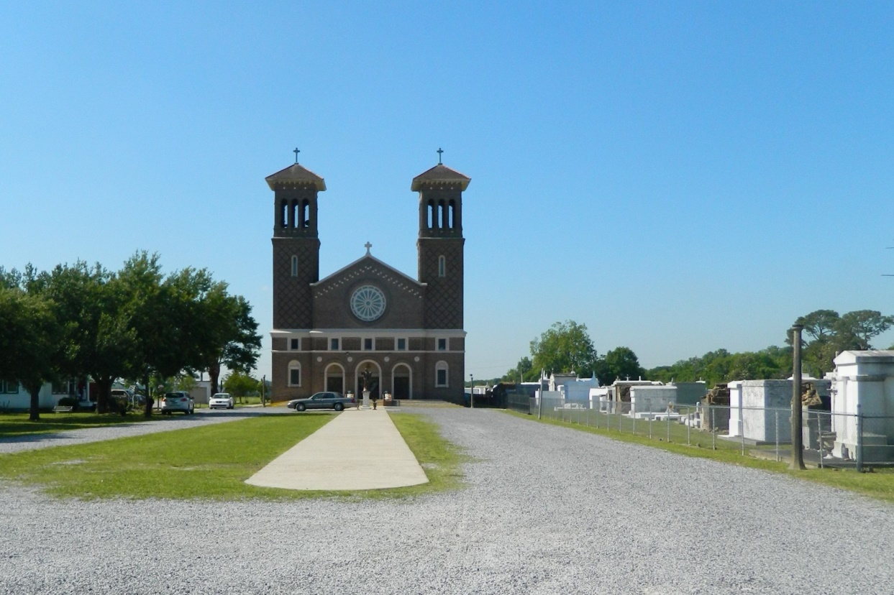

On Saturday, January 20, 2018, Avis Alexander Jessie entered into eternal rest. She was the daughter of Theresa Alexander and Theodore Moll. Avis was a graduate of Second Ward High School’s Class of 1966. She attended Nichols State University in Thibodaux, where she was enrolled for two years in Nichols School of Nursing. She was a retiree of St. James Youth Center.   
Avis leaves to cherish her memory; daughter, Niki Jessie; grandson Collin Jessie; sisters, Margo Lumar, and Demetre Bailey; and brothers Nathaniel and Grant Walker. She also leaves behind a loving extended family of nieces, nephews, cousins, godchildren, and devoted friends. She was preceded in death by her mother, Theresa Alexander, her sister and brother, Marsha and Lynwood Walker and niece Rachelle Walker.

Relatives and friends of the family, also Pastor and members of Our Lady of Peace, Vacherie, LA, St. John the Baptist Catholic Church and surrounding churches, employees of St. James Youth Center, Lafourche Parish Juvenile Justice, UCC/Dow Chemical Co, Galata Chemicals, Monsanto Chemical Co. Fluor Daniels are invited to attend a Mass of Christian Burial on Saturday, January 27, 2018 at 11:00 am from St. John the Baptist Catholic Church, 2349 Hwy 18 in Edgard, LA. Father Robustiano Morgia, celebrant. Visitation 8:30 – 11:00. Entombment Church Mausoleum. There will be gathering of friends on Friday January 26, 2018, 6-8pm at Treasures of Life Funeral Services 315 E. Airline Hwy. Gramercy, La.   
  
“When someone you love becomes a memory that memory becomes a TREASURE” [www.treasurefunerals.com](http://www.treasurefunerals.com) (accessed 10/7/2018)