Early Johnson

June 6, 1915 – January 26, 2003

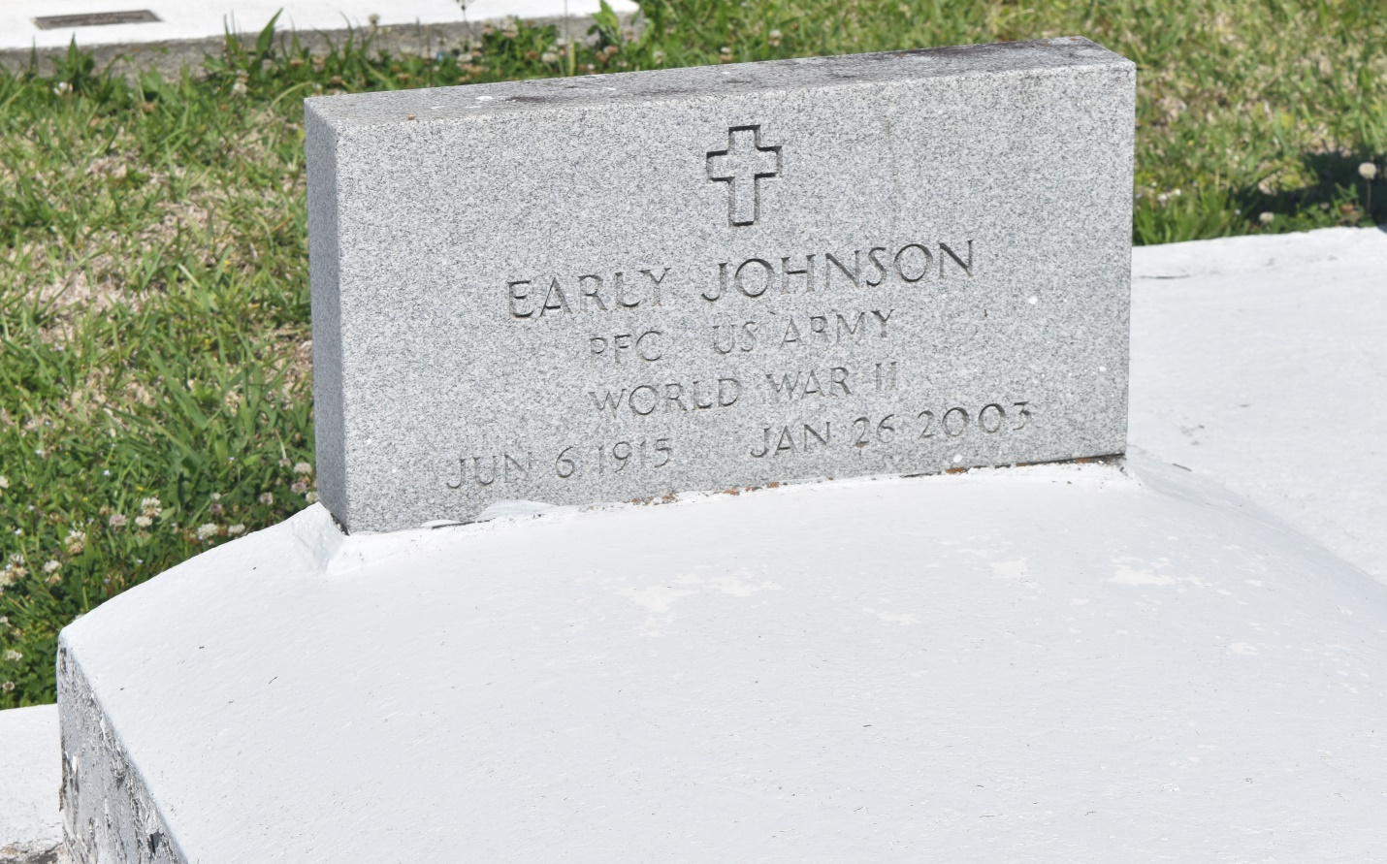

EDGARD - Early Johnson, 87, a native and resident of Edgard, died Jan. 26. He was the husband of Genevia Isaac Johnson and stepfather of Herbert LaGrange, Olivia Mason and the late Charles LaGrange.  
  
He is also survived by a host of grandchildren and great-grandchildren.  
  
Services were Jan. 31 at St. John the Baptist Catholic Church, Edgard, with interment at the church cemetery.

L'Observateur (La Place, LA) - Tuesday, February 4, 2003

Contributed by Jane Edson