Alfroncine M. (Louper) Jones

November 15, 1918 – March 21, 2006

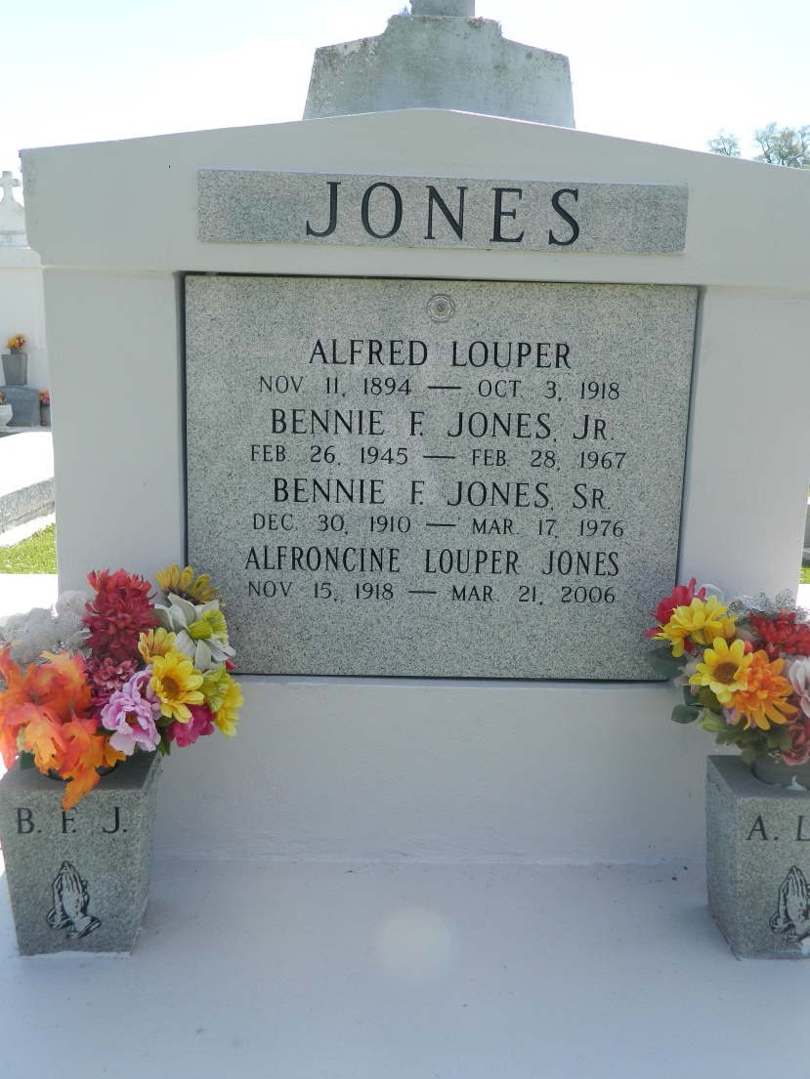

EDGARD - Alfroncine M. Louper Jones, 87, a native of Edgard and a resident of New Orleans, died March 21. She was the wife of the late Bernie Jones Sr.  
 She is survived by a daughter Lovida Johnson. She is also survived by son-in-law and daughter-in-law Edward Johnson and Annie Mae Jones Brannon, cousins Morris Alexander, Gladys Smith, Bert Sylvin, uncle Melvin Louper, nine grandchildren and eight great-grandchildren.  
 She was preceded in death by her parents Alfred and Leona Alexander Louper and son Bernie Jones Jr.  
 Services will be held March 28 at St. John the Baptist Catholic Church, Edgard, with interment in the church cemetery.  
 The Baloney Funeral Home of Garyville is in charge of arrangements. Visitation begins at 9 a.m. at the church.

L'Observateur (La Place, LA) - Monday, March 27, 2006

Contributed by Jane Edson