Margo Theresa (Samuel) Joseph

December 22, 1956 – May 21, 2011

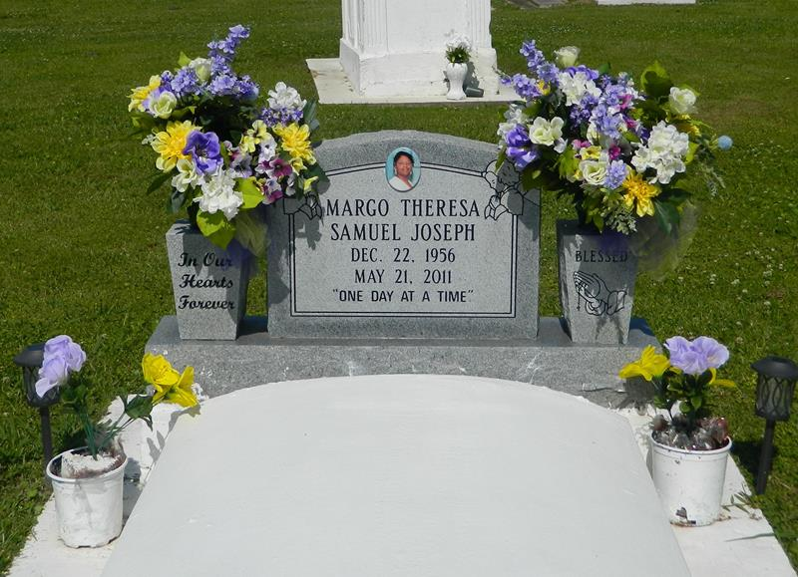

Margo Theresa Samuel Joseph was born in Vacherie, La. on December 22, 1956 to Norman Jr. and Mildred L. Samuel of Edgard, La. She died on Saturday, May 21, 2011 at her residence in Edgard, La. at the age of 54. Loving wife of Louis Joseph. Devoted mother of Tashana (Jarrett) Gaudet and Malana Joseph. Loving grandmother of Jashan and Jaidynn Gaudet. Sister of Mayta Samuel, Myra (Lawrence) Borne, the late Thaddeus (Olita) Samuel. Devoted aunt of Lakeyta Samuel and Meghan Borne. Caregiver of Janaja Palao. Granddaughter of the late Horace and Alma Lumar; the late Norman, Sr. and Estella Samuel. Daughter-in-law of the late Morris Sr. and Florence Baker Joseph. Sister-in-law of Raymer, Florence, Larry Joseph, Olivia Fiffie (Alvin), Carolyn Gullage (Albert), Lawrence (Genevieve), Elizabeth Johnson (Reginald), the late Janice London (Royal), the late Morris Joseph, Jr. and the late Rosemary Gullage (William) Godmother of Akela Lumar and Meghan Borne. Goddaughter of Margaret Lumar and Alvin Collins. Niece of Anderson (Elona) Lumar, Brenetta (George) Dunmiles, Darrell (Maxine) Lumar, Harold Lumar, Eula Johnson, Julia Joseph, Ronald Samuel, Sr., Riley Samuel, Henry (Josephine) Samuel. Margaret Lumar, Lena (Calvin) Pollard. Survived by a host of devoted cousins, other relatives and many good friends.  
 Graduated from Second Ward High, Edgard, La. Class of 1974; Dillard University 1978. Employed as Regional Manager for Region 3 Department of Health & Hospital State of Louisiana. Member of Delta Sigma Theta Sorority, Inc. Baton Rouge Sigma Alumnae Chapter. Margo Joseph was a compassionate, tender-hearted and humble-minded person. She lived life to its fullest and laughed often. She looked for the best in others and gave the best she had. Her smile and whatever way she touched your life will be forever remembered.  
 Mass of Christian Burial at 11:00 a.m. at St. John the Baptist Catholic Church, 2361 Hwy. 18, Edgard, La. Visitation begin at 8:30 a.m., recitation of the Rosary at 9:30 a.m., Delta Sigma Theta Sorority Omega Omega Service at 10:00 a.m. Father Joel Cantones, officiating. Burial will be in the Church Cemetery. Invited to attend are: St. John the Baptist Catholic Church parishioners, Region 3 Department of Health & Hospitals, Tri-Parish Medical, Dow St. Charles Operation, St. John District Attorney office, St. John Parish School System, Port of South Louisiana, Second Ward High Class of 1974, Baton rouge Sigma Alumnae Chapter, New Orleans alumnae Chapter, River Parish Community College, Nicholls State Athletic Association, Monsanto Chemical, Greater New St. Peter Baptist Church and neighboring churches.  
 Arrangements by the Baloney Funeral Home LLC, 399 Earl Baloney Street, Garyville, La. 985-535-2540. Guest may sign the register at [www.baloneyfuneral.com](http://www.baloneyfuneral.com/).

Times-Picayune, The (New Orleans, LA) - Friday, May 27, 2011

Contributed by Jane Edson